Interfaith Afternoon Tea in the House of Lords for World Interfaith Harmony Week 2018
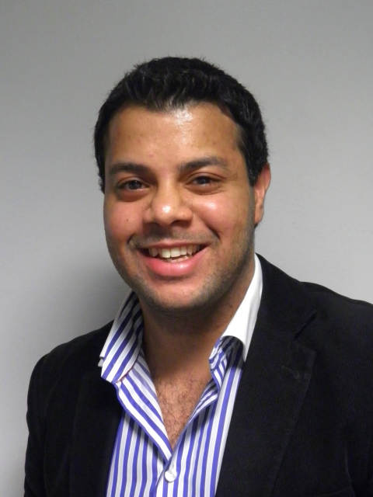
My name is Cllr Hashim Bhatti and I have been voluntarily working in the interfaith sector for the last 10 years alongside my other commitments in corporate law.

I have been involved with an organisation called Three Faiths Forum (the UK’s largest interfaith charity) and went through their ParliaMentors programme to setup the Alumni Committee and the UK’s first Interfaith Summit.

As part of World Interfaith Harmony Week 2018, I am organising an Interfaith Afternoon Tea in the House of Lords for 14 young leaders which is being sponsored by Lord Mohamed Sheikh (the first UK Muslim peer).

The aim of the tea is to bring together 14 young leaders from different faith backgrounds and organisations to share stories about their past and future projects, to discuss best practices in the sector and to explore opportunities to collaborate with the overall goal of walking away understanding each other better. I hope by exploring what projects have worked and those that haven’t, new opportunities are created to strengthen community cohesion in the UK.

I also hope that other UK faith organisations can see that they don’t need to compete with one another but instead each of them is complimentary and can work together.

Young representatives from several of London’s leading faiths organisations such as Three Faiths Forum and Faiths Forum have confirmed their attendance.

This event is unique and has never been done before in a parliamentary setting in the UK especially not voluntarily by a young Muslim in his 20’s. It is an event organised by a young Muslim for other young leaders who are the future.

Finally, any award or money raised will not be going to me but will be donated to the Alumni committee so that we can host the fourth UK Interfaith Summit later this year which will further help UK civil society. This award means so much to me and the alumni committee.

Please note the tea was expected to take place at the end of February but due to Lord Sheikh’s commitments it was pushed back to 19th March 2018. Pictures to follow.

I also snorkelled in Mexico in January 2018 to raise awareness of the world interfaith harmony week despite hating swimming.

Yours sincerely,
Cllr Hashim Bhatti

