EVENT REPORT
CHECKLIST

Kingdom of Morocco.

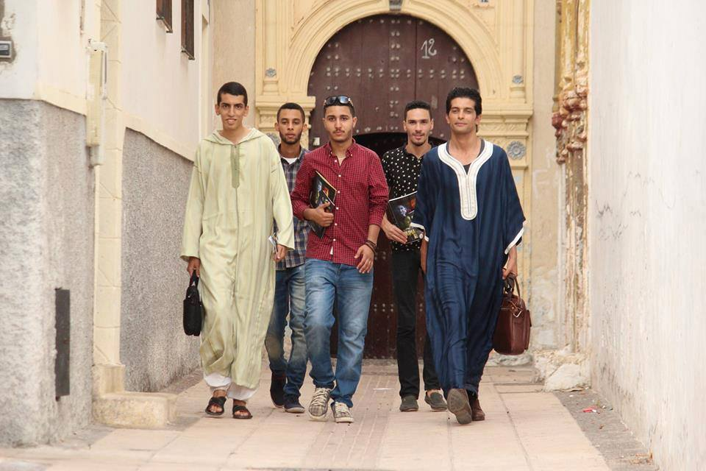
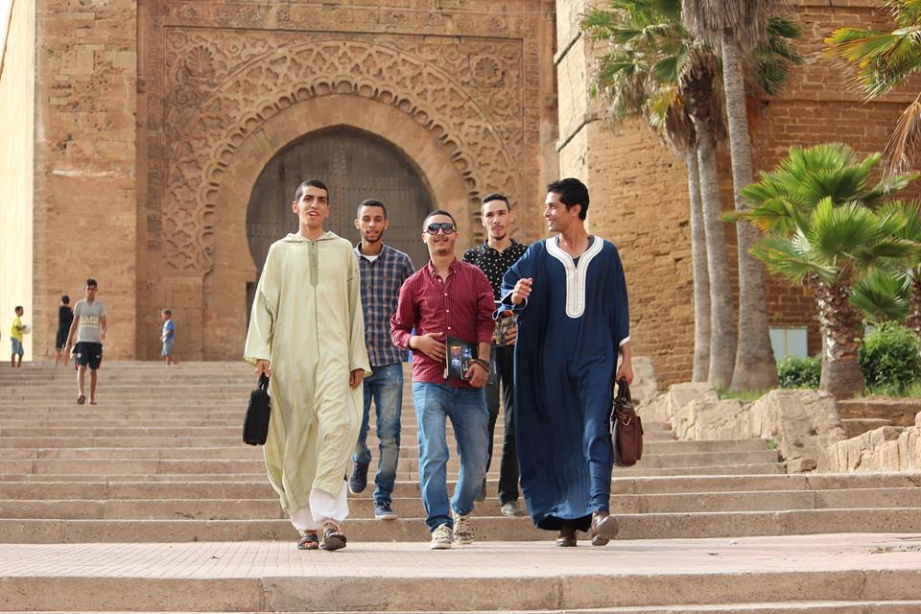
Youth for Peace and Youth for Human rights Team in Rabat

Rabat is the capital of Morocco and its seventh largest city center with an urban population of approximately 580,000 and a metropolitan population of over 1.2 million. It is also the capital of the Rabat-Salé-Kénitra administrative region.

The city is located on the Atlantic Ocean at the mouth of the river Bou Regreg. On the facing shore of the river lies Salé, the city's main commuter town. Rabat, Temara, and Salé form a conurbation of over 1.8 million people. Silt-related problems have diminished Rabat's role as a port; however, Rabat and Salé still maintain important textile, food processing and construction industries. In addition, tourism and the presence of all foreign embassies in Morocco serve to make Rabat one of the most important cities in the country.

Once a reputed corsair haven, Rabat served as one of the many ports in North Africa for the Barbary pirates, who were particularly active from the 16th through the 18th centuries.

Rabat is accessible by train through the ONCF system and by plane through the nearby Rabat–Salé Airport.

The Moroccan capital was ranked at second place by CNN in its "Top Travel Destinations of 2013.It is one of four Imperial cities of Morocco, and the medina of Rabat is listed as a World Heritage site

Meeting with The Moroccan Human Rights Organization.
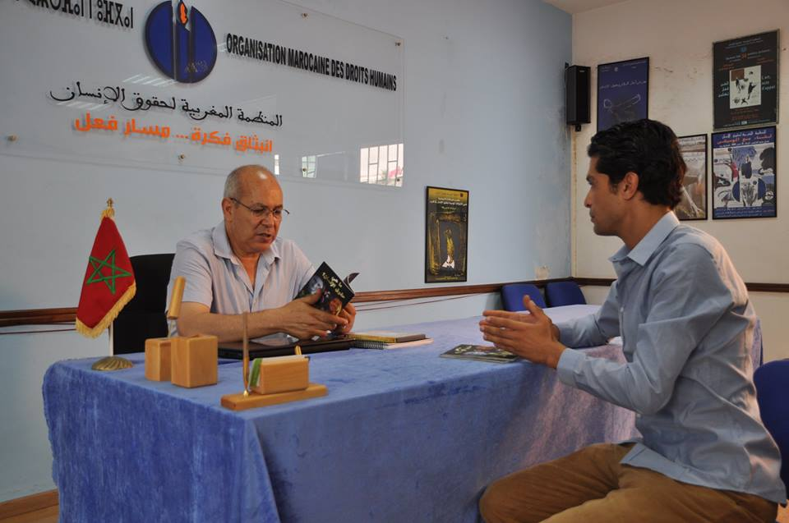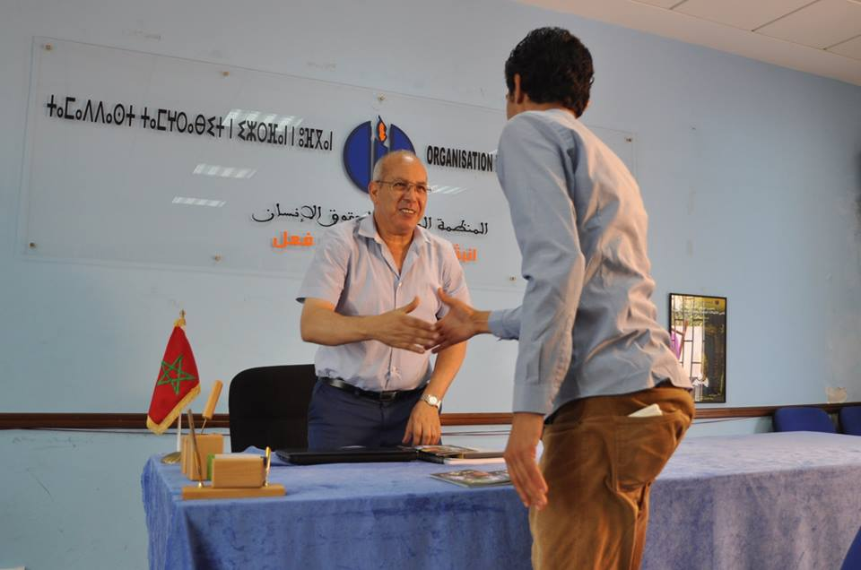

Introducing our works to Mr Boubker Largo President of The Moroccan Human Rights Organization (OMDH) . founded in 1988 by a group of Moroccan professionals to address the problem of human rights violations in the kingdom. Among the goals of the organization are the promotion of knowledge about individual and collective human rights at the civil, political, and socioeconomic levels, the protection of human rights, the reinforcement of the rights of the individual during the judiciary process, promotion of democracy and the rule of the law. The OMDH is a member of the International Federation of Human Rights, based in Paris, the International Commission of Jurists, based in Geneva, the World Organization against Torture, based in Geneva, and the Arab Organization of Human Rights, based in Cairo. The organization periodically cooperates with international and regional organizations, such as the Association Marocaine des Droits Humains, the Ligue Marocaine pour la Défense des Droits de l'Homme, and the Comité de Défense des Droits Humaines.

Mr largo promised that he will works with youth for Human rights and sing partnership agreement in order to promot and use YFH materials in public schools and human rights club.the meeting with Mr Largo was arranged by Mustapha Mezroui Chargé de mission ;Eduquer et sensibiliser à l’abolition de la peine de mort au Maroc.
Bouznika
Bouznika is a city in Casablanca-Settat, Morocco, in the historical region of Chaouia.
The city name means "son of the small alley" in Arabic.
The city is part of the territory of Zenata, a Zenata Berber tribe introduced in the area when the Almoravids conquered the region. In 1907, when the French arrived in Casablanca, they took up arms cons them, they did so without conviction and were the first to submit. It was part of the group Oulad Bou Rezq and are now part of the group Chehaouna, it is divided into 8 fractions: Ouled Sidi Ali, Khalta, Oulad Hedjala, Ouled Maza, Berrada, Beni Meghith and Ghezouan. The inhabitants also come from Ziaida, a Sanhaja Berber tribe, very hospitable to those who fled the Makhzen, she was very mixed and it is not uncommon to see one of them claiming Arab. The rest of the inhabitants comes from the Arab tribe of the Banu Hilal, installed by the Almohads and the Almoravids to the 12th century.

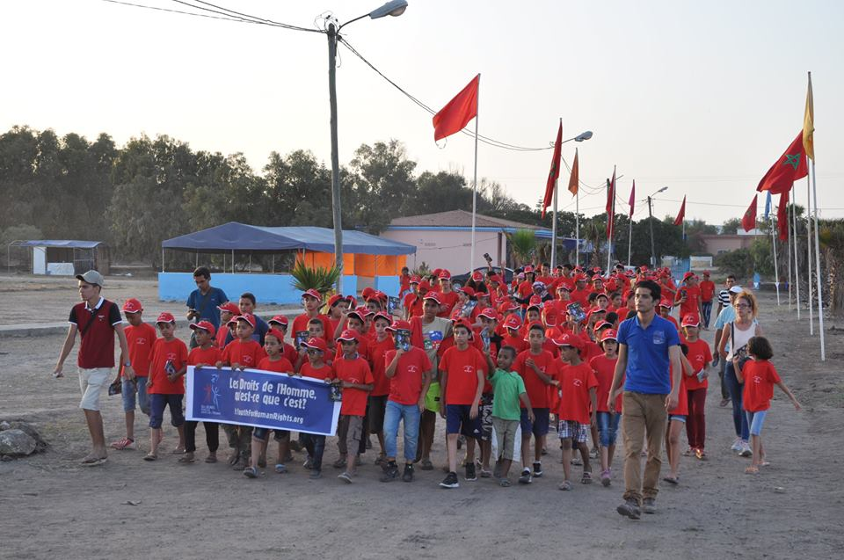
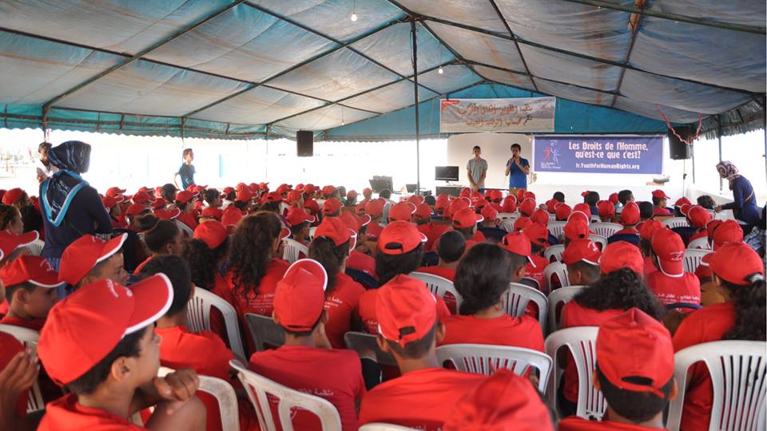
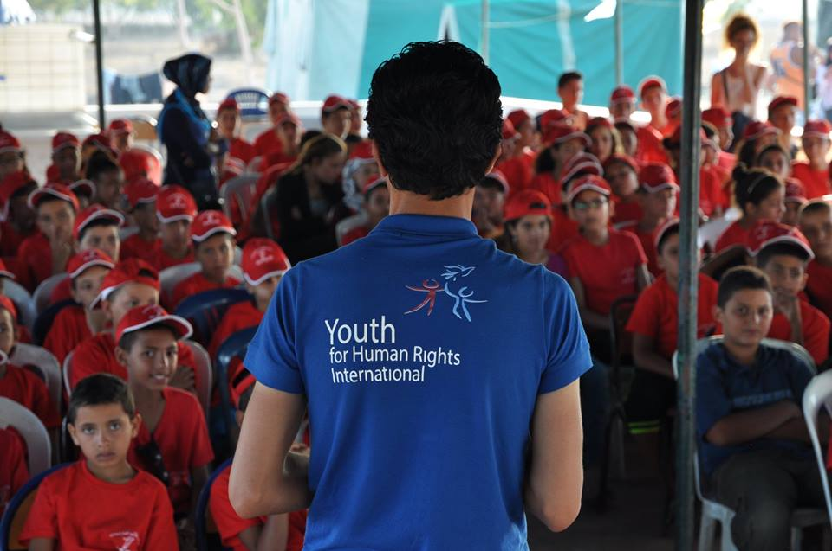

Workshop at Youth camp orgnized by Oraganisation des pionniers enfants du Maroc organization that promot the culture of human rights for kids almost 200 kids attend the workshop to learn about the story of human rights and the 30 videosto inspire them to become advocate for Peace and Tolerance
We are surprised that kids know already what human rights are,they said the video are amazing and they learn with fun human rights.The director of youth camp in Bouznika said to the team of YFH that they are doing great job in Morooc to inspire youth to become advocate for peace and tolerance.

Rabat.
Mominoun Without boders foundation is a center for study and research, founded in May 2013. It is concerned with the renewal of the research and academic knowledge in the cultural and cognitive domains generally, and religious ones particularly. The foundation’s interests are to study the institution of the founding ideas of systems of cultural thinking in the region and seek, in a scientific side, to test the progress of cultural, sociological and intellectual actors in the Arab and Islamic world, in theory and in reality. And, to achieve this, the foundation takes the path of open, efficient and effective criticism in examining all ideas, without bias or prejudice; except that is related to human rights in its reality and existence.
The Foundation's vision has its source in the heart of its faith in the usefulness of betting on human charity, and faith in his unlimited value, and belief in the need to guide the purposes of intellectual and political debate as an objective to his happiness upstream of the kinetics of history, and that, as a spiritual and moral requirement itself constituting a primary coronation which should not be remote from his compass, amidst all the complexities of life in its existential and spiritual details.

Therefore, the highest priority actually; Place now into the foundation responsibility to put maximum attention to anything that can help researchers and thinkers, make thoughtful investigation of new aid flows. Accordingly, the foundation is committed to supporting the creativity of serious researchers, including younger ones. It promotes their research and various works and deepens the Arab-Islamic intellectual controversy, supporting civic development to guide the theoretical and scientific methods that can facilitate collective response to the need to achieve the horizon of peace, and building awareness and knowledge in both reality as in thoughts.
Are that the human is greater than restricting his kindness to his religion , race or sect; and that the dignity of the human being and his happiness lies in respect of his freedom to think, speak and believe, and elevate the values of social and cultural differences without racial, religious or sectarian discrimination.
Are that: totalitarian visions whatever their sources are , do not cohere with the different people and nations, nor with their cultural diversity and plurality ; and violate the first axioms of human existence that is absolute respect for living together on the same land ; and that the violation under any circumstances ,of the principles of freedom, human rights and the scope of civil society, can cause direct and indirect suffering, heavy losses , wars and conflicts, hate between nations and peoples ; and that respect for the culture of others and even to defend and preserve it, is a protection of our identity and our humanity, and an assurance of our security and our freedom.
Above all discrimination and racial, religious, cultural or sectarian difference. A belief representing brotherhood and goodness in all the splendor of its meaning; which drives man to achieve this splendor in his action, behavior and thought, and creates the confidence in his ability to open up to other human culture, and that this infinite belief and consciousness that educated humans are capable of supporting mental maturity and cognitive movement to build their human civilization and raise their societies .

Introducing human rights education At Mominoun Without Borders. :

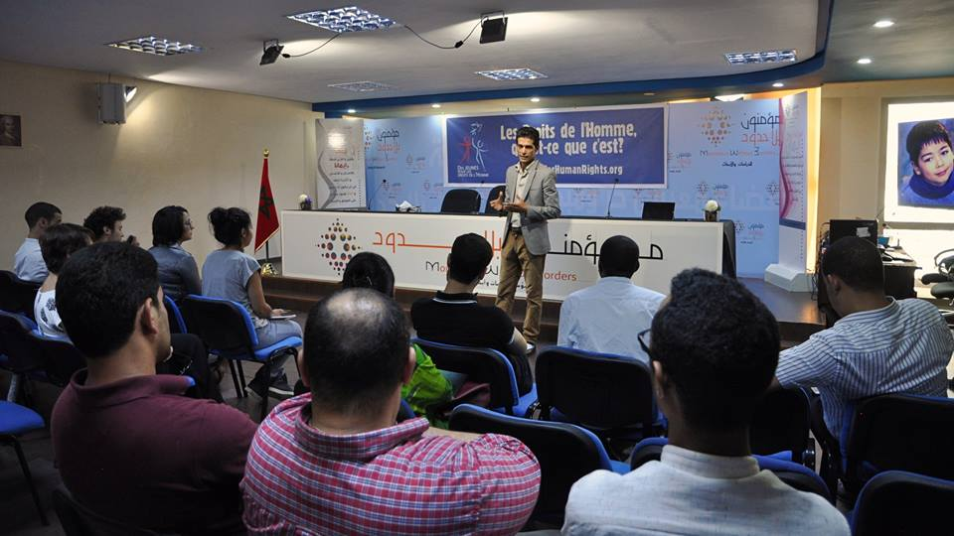
The meeting was arranged by Nezha Saddik President of Public relationship at Mominoun Without Borders.Rabat.Nezha Saddik said that she loves the works of Youth for Human rights to educate the youth human rights in defrent way.she is ready to work with Moroccan representative Zakaria El hamel in order to orgnize more workshop and meeting in her fondation.she said that our fondation is open to youth for human rights anytime !
Nezha wants to attend Human rights summit and she already goth er official inviation.

Panama Embassy.
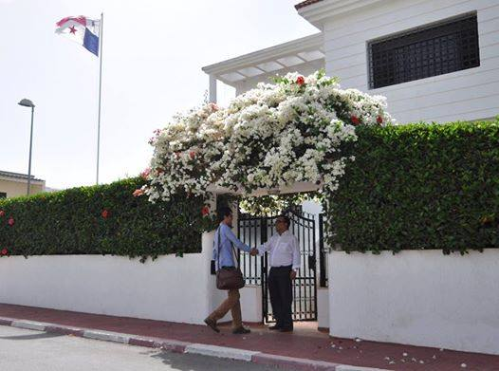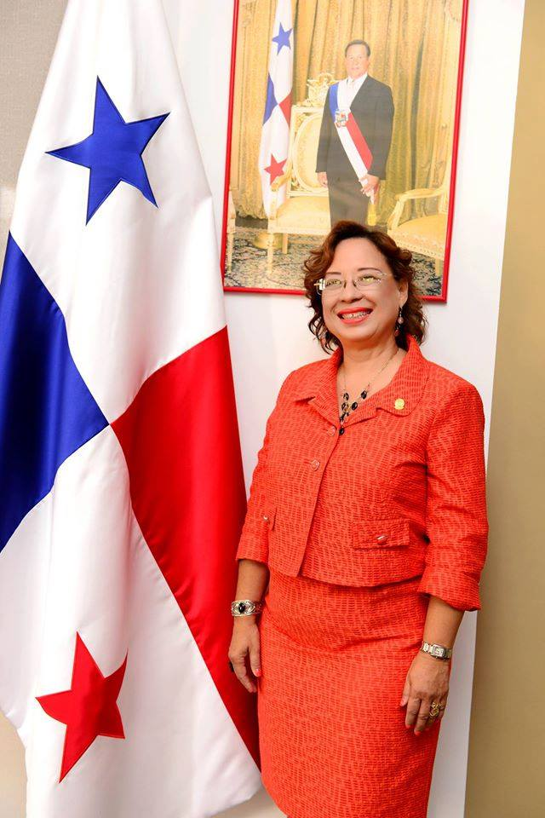
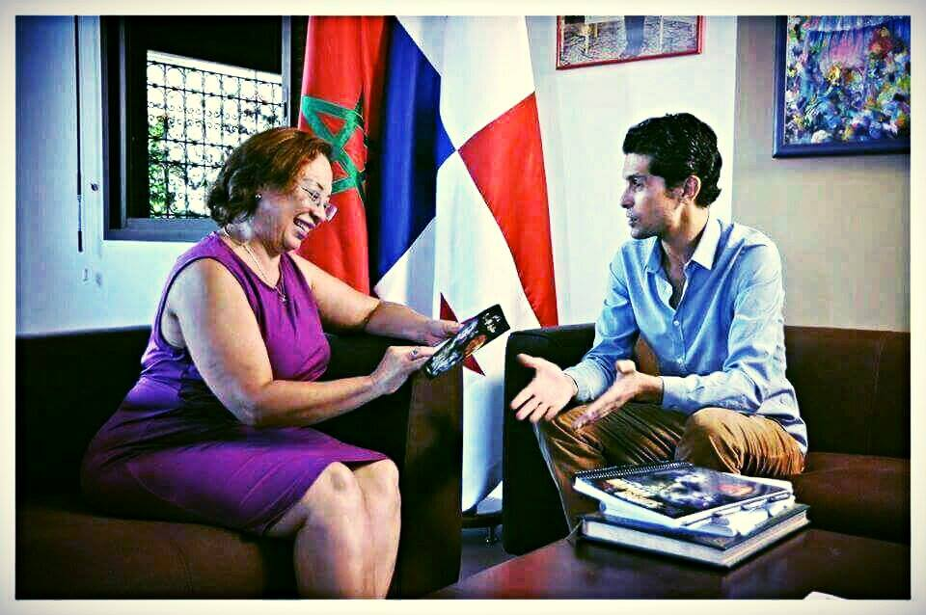

In April 2014 Panama inaugurated its first embassy in Rabat in the presence of the Panamanian vice Minister of Foreign Affairs, Mayra Arosemena and several Moroccan officials.

The panama Ambassador already knows the work of Zakaria El hamel as president of Youth for Peacfe in Morocco before she was appointed ambassador in Morocco.some of her friends in panama told her about his works she called him 6 months ago in order to make a visit to his organization oujda.as the team of human rights comes to Morocco Zakaria called the ambassador for a meeting she accepted with honor.

Mme Gloria young host Zakaria El hamel and his team in her office in Rabat with juice and cookies and they start talking about international issues and interfaith peacebuillding and about Youth for human rights tour in Morocco.

Gloria young appreciate cery much the 30 video .Zakaria showed her the first video we are all born free and equeal and the story of human rights in portuguese language.
Gloria Young suggest to do the same works in panama with the youth and spread the message of World interfaith harmony week because she wants to change the world as Panama is in progress .
The meeting with The Amazing Gloria young was son wonderful iam optimistic that we can do something for youth in both countries .Said Zakaria El hamel.

Marrakesh
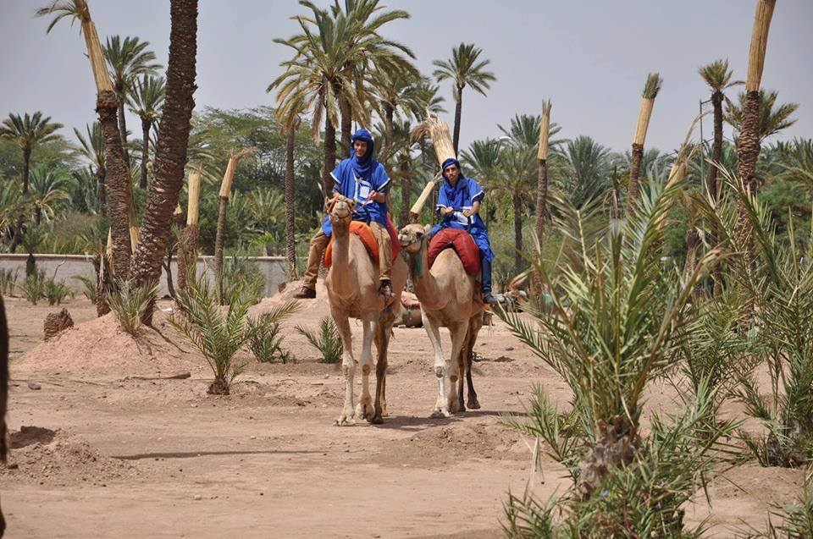
Marrakesh is a major city of the Kingdom of Morocco. It is the fourth largest city in the country, after Casablanca, Fes and Tangier. It is the capital city of the mid-southwestern region of Marrakesh-Safi. Located to the north of the foothills of the snow-capped Atlas Mountains, Marrakesh is located 580 km (360 mi) southwest of Tangier, 327 km (203 mi) southwest of the Moroccan capital of Rabat, 239 km (149 mi) south of Casablanca, and 246 km (153 mi) northeast of Agadir.

Marrakesh is possibly the most important of Morocco's four former imperial cities (cities that were built by Moroccan Berber empires). The region has been inhabited by Berber farmers since Neolithic times, but the actual city was founded in 1062 by Abu Bakr ibn Umar, chieftain and cousin of Almoravid king Yusuf ibn Tashfin. In the 12th century, the Almoravids built many madrasas (Koranic schools) and mosques in Marrakesh that bear Andalusian influences. The red walls of the city, built by Ali ibn Yusuf in 1122–1123, and various buildings constructed in red sandstone during this period, have given the city the nickname of the "Red City" or "Ochre City". Marrakesh grew rapidly and established itself as a cultural, religious, and trading centre for the Maghreb and sub-Saharan Africa; Jemaa el-Fnaa is the busiest square in Africa.

After a period of decline, the city was surpassed by Fes, but in the early 16th century, Marrakesh again became the capital of the kingdom. The city regained its preeminence under wealthy Saadian sultans Abu Abdallah al-Qaim and Ahmad al-Mansur, who embellished the city with sumptuous palaces such as the El Badi Palace (1578) and restored many ruined monuments. Beginning in the 17th century, the city became popular among Sufi pilgrims for Morocco's seven patron saints, who are entombed here. In 1912 the French Protectorate in Morocco was established and T'hami El Glaoui became Pasha of Marrakesh and held this position nearly throughout the duration of the protectorate until the role was dissolved upon independence of Morocco and the reestablishment of the monarchy in 1956. In 2009, Marrakesh mayor Fatima Zahra Mansouri became the second woman to be elected mayor in Morocco.

Like many Moroccan cities, Marrakesh comprises an old fortified city packed with vendors and their stalls (the medina), bordered by modern neighborhoods, the most prominent of which is Gueliz. Today it is one of the busiest cities in Africa and serves as a major economic centre and tourist destination. Tourism is strongly advocated by the reigning Moroccan monarch, Mohammed VI, with the goal of doubling the number of tourists visiting Morocco to 20 million by 2020. Despite the economic recession, real estate and hotel development in Marrakesh has grown dramatically in the 21st century. Marrakesh is particularly popular with the French, and numerous French celebrities own property in the city. Marrakesh has the largest traditional market (souk) in Morocco, with some 18 souks selling wares ranging from traditional Berber carpets to modern consumer electronics. Crafts employ a significant percentage of the population, who primarily sell their products to tourists.

Marrakesh is served by Ménara International Airport and the Marrakesh railway station, which connects the city to Casablanca and northern Morocco. Marrakesh has several universities and schools, including Cadi Ayyad University. A number of Moroccan football clubs are located here, including Najm de Marrakech, KAC Marrakech, Mouloudia de Marrakech and Chez Ali Club de Marrakech. The Marrakesh Street Circuit hosts the World Touring Car Championship, Auto GP and FIA Formula Two Championship races.

Jamaa el Fna

Jamaa el Fna is a square and market place in Marrakesh's medina quarter (old city). It remains the main square of Marrakesh, used by locals and tourists.
The origin of its name is unclear: Jemaa means "congregation" in Arabic, probably referring to a destroyed Almoravid mosque. "Fanâʼ" or "finâ'" can mean "death" or "a courtyard, space in front of a building." Thus, one meaning could be "The assembly of death," or "The Mosque at the End of the World".Another explanation is that it refers to a mosque with a distinctive courtyard or square in front of it.A third translation is "assembly of the dead", referring to public executions on the plaza around 1050 AD.

During the day it is predominantly occupied by orange juice stalls, water sellers with traditional leather water-bags and brass cups, youths with chained Barbary apes and snake charmers despite the protected status of these species under Moroccan law.
As the day progresses, the entertainment on offer changes: the snake charmers depart, and late in the day the square becomes more crowded, with Chleuh dancing-boys (it would be against custom for girls to provide such entertainment), story-tellers (telling their tales in Berber or Arabic, to an audience of locals), magicians, and peddlers of traditional medicines. As darkness falls, the square fills with dozens of food-stalls as the number of people on the square peaks.
The square is edged along one side by the Marrakesh souk, a traditional North African market catering both for the common daily needs of the locals, and for the tourist trade. On other sides are hotels and gardens and cafe terraces, and narrow streets lead into the alleys of the medina quarter.

he idea of the UNESCO project Masterpieces of the Oral and Intangible Heritage of Humanity came from people concerned about the Jamaa el Fna. The place is known for its active concentration of traditional activities by storytellers, musicians and performers, but it was threatened by economic development pressures. In fighting for the protection of traditions, the residents called for action on an international level, to recognize the need for the protection of such places — termed "cultural spaces" — and other popular and traditional forms of cultural expression.

UNESCO encourages communities to identify, document, protect, promote and revitalize such heritage. The UNESCO label aims to raise awareness about the importance of oral and intangible heritage as an essential component of cultural diversity.

“ The spectacle of Jamaa el Fna is repeated daily and each day it is different. Everything changes — voices, sounds, gestures, the public which sees, listens, smells, tastes, touches. The oral tradition is framed by one much vaster — that we can call intangible. The Square, as a physical space, shelters a rich oral and intangible tradition. ”
— Juan Goytisolo, in a speech delivered at the opening meeting for the First Proclamation,
At Jamaa el Fna Marrakesh :
Fostering Religious Harmony through Human Rights Education
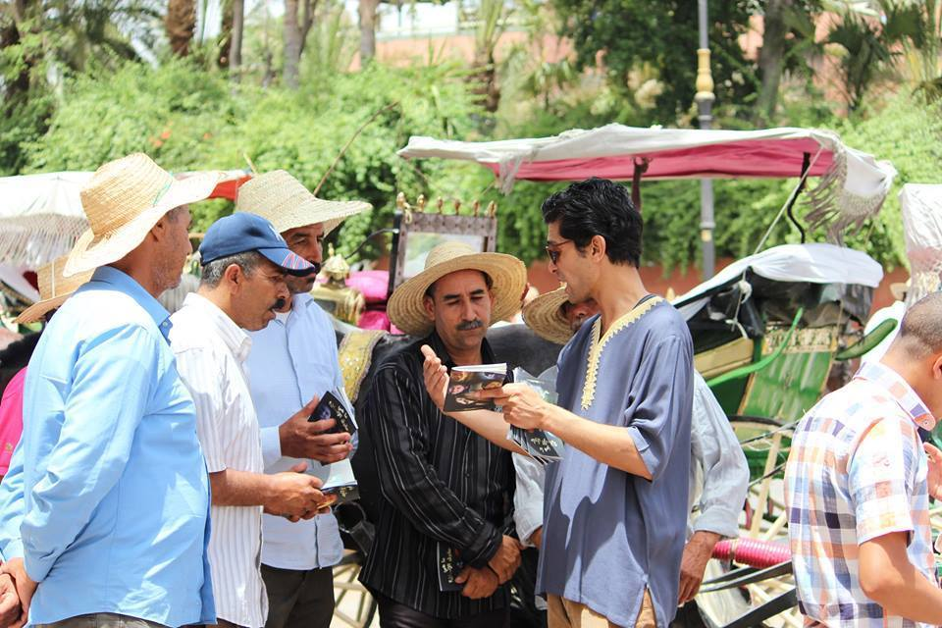

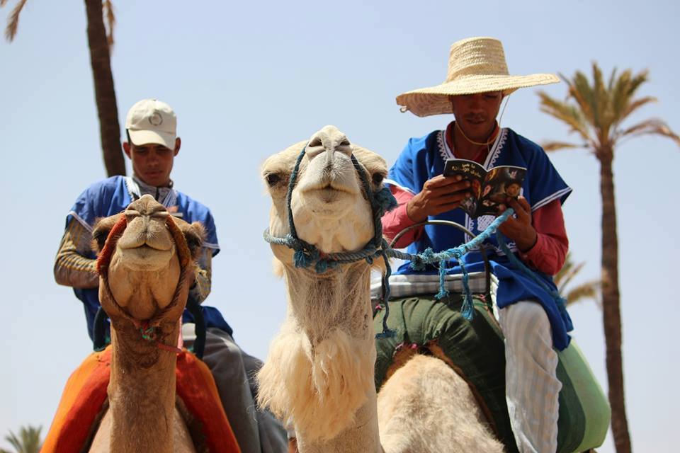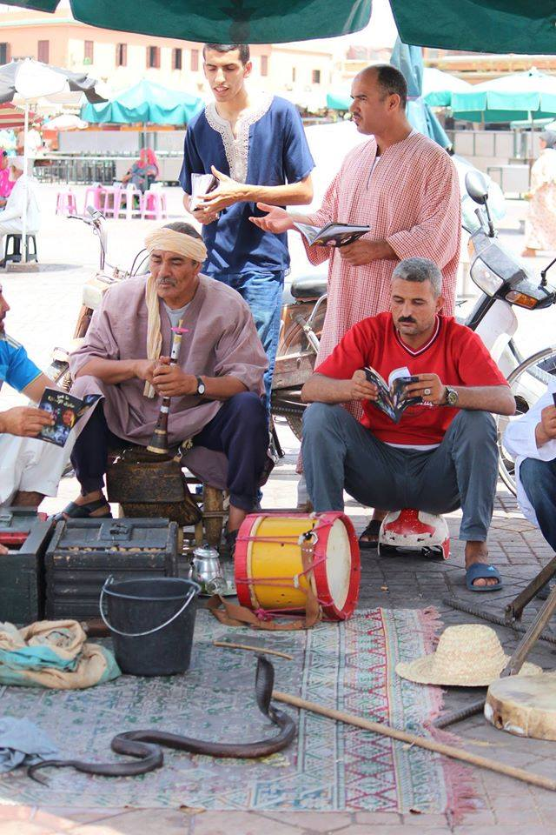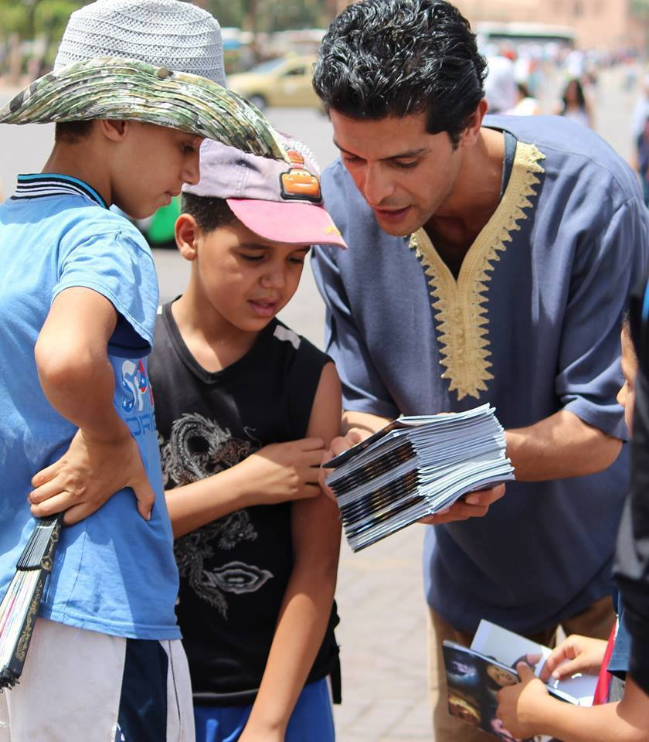

In coordination with the section of Moroccan organization for human rights theMoroccan team distribute the booklet and try to explain to them what human rights are and why interfaith harmony is so important ..The people that we meet in this city welcome us the snake charmer said that he will show his youth the booklets so that they can learn more about human rights sot hey become advocate for peace and tolerance

Parliament of Morocco
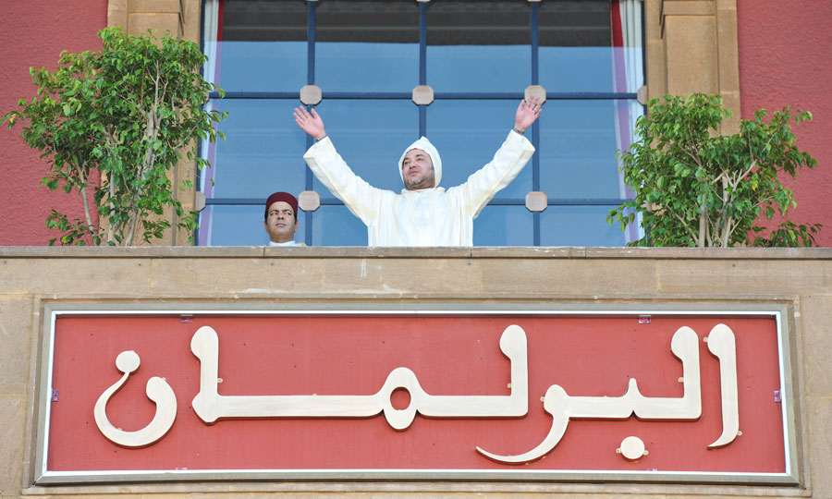
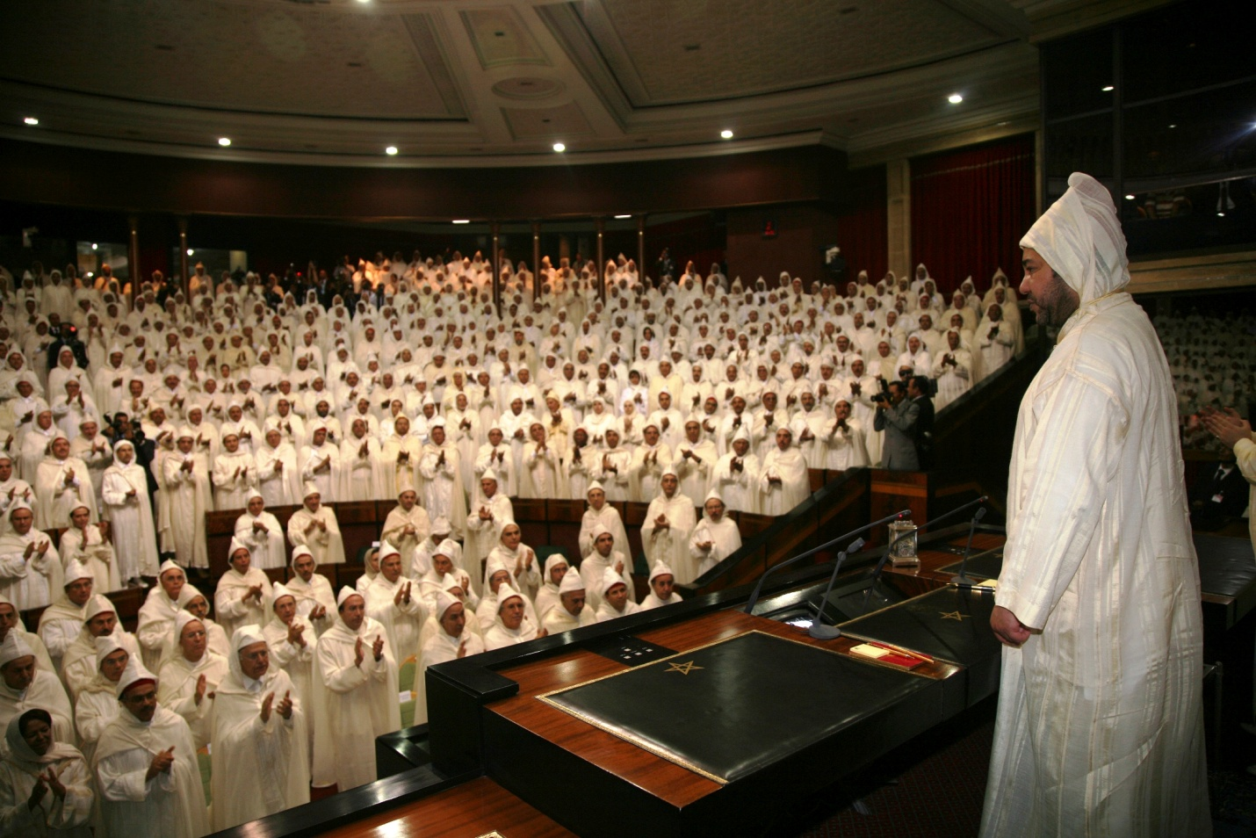

The Parliament of Morocco is the bicameral legislature located in Rabat, the capital of Morocco.
The traditional representative system in Morocco was organized through traditional structures such as the ulema assembly by cities and regions, or the Jemaa assembly within the tribes. These structures were not elected, but nominated through an cooptation system.

From 1880, Morocco began a range of reforms to adapt its institutions to modern standards. Among these reforms the creation of the position of grand vizier, having a structured and durable cabinet, with six ministries, including foreign affairs, finance, defense etc .. In the process, the Sultan Moulay Abdelaziz decides create a consultative assembly in 1904, he named Majlis el Aayane.It is this assembly that summoned the international conference of Algeciras, and that has drafted the constitution of 1908, which 'never entered into force because of the political unrests.

The Majlis el Ayane has been dissolved in 1913, as a result of the Treaty of Fez establishing a protectorate. But since 1947, and on impulse Erik Labonne, Resident General of France in Morocco, and the Sultan Mohammed V, the protectorate creates consultative chambers reserved for moroccans, Jews and Muslims. These elected chambers, through the elections of 1947 and 1951, were in reality only a weak response of the protectorate system to the nationalists claims expressed en 1944 manifesto of independence. The Istiqlal who accept to participate in the 1947 elections, earning three elected representatives, eventually boycott the 1951 elections.

At the end of 1955, and after the return from exile of Sultan Mohammed V, November 16 , and the victory of nationalists, Morocco adopted in a first step, a non-elected parliament, resulting from consultations with the main political parties to lay the foundations for future elections. The first chamber was chaired by Mehdi Ben Barka. The first Moroccan Constitution adopted in 1963 created a bicameral parliament consisting of the House of Representatives and House of Councillors.

The 1970 Constitution abandon bicameralism and opts for a single room. The 1992 Constitution allows elected to create committees of inquiries.

Under the state of emergency, the Head of State (in this case the King of Morocco) may dissolve Parliament, "the state of exception does not cause the dissolution of parliament" ( Article 35, paragraph 2 of the 1972 constitution revised in 1996). During the years of lead - under the reign of Hassan II - the right was quite improperly invoked, since the first and only state of emergency that gripped the Morocco lasted five years, from June 1965 to July 1970. However, constitutions adopted after that date contained many restrictions of public freedoms, close to the state of emergency. Until 1977, no elected parliament has completed its term.
Since 1996, the national legislature has become bicameral and has therefore two parliamentary chambers:

The House of Representatives or the lower house. 395 members elected directly for a five-year term.
The House of Councillors. It is elected indirectly for a nine-year term by two sets of electoral colleges.
The Members of Parliament come from Morocco and the Moroccan-held parts of Western Sahara (under Moroccan law treated as the Southern Provinces).
Part of the reserve powers, the head of State (in this case the King of Morocco) has the right to dissolve the Parliament. In the past, during the "years of lead" under King Hassan II, this right was used extensively, along with suspensions and extensions of terms. Thus, until 1997, not a single elected Parliament was able to complete its term under normal circumstances.
The role of Parliament, and the respect of the monarchy for its integrity, has increased considerably since 1999, when Mohammed VI took the throne. However, the power of Parliament is still being limited as it is the King who appoints the prime minister and on proposition from the latter, the members of government.

Meeting with Naima Farah member of Moroccan Parliament :
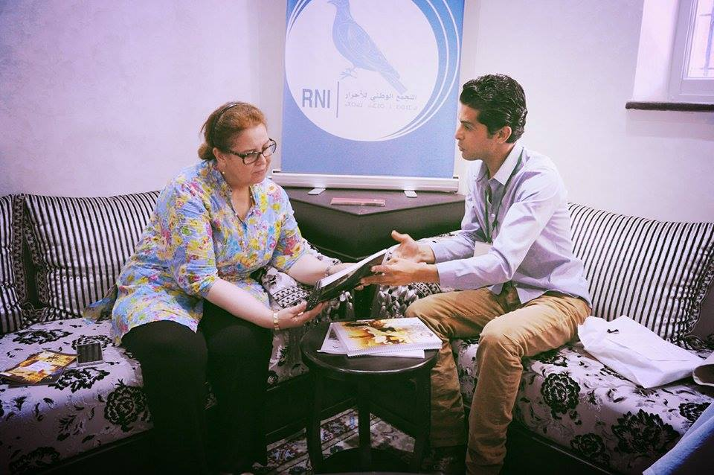

Born in Casablanca, Ms. Naima Farah holds a diploma of higher studies in Arabic literature. She is preparing her PhD on 'passion in the Andalusian literature through the writings of Ibn Arabi and Ibn Hazme'. After a long experience in journalism as a member of the newspaper Al Watani Al Mitaq ', Ms. Farah has held several positions in ministerial offices, such as study investigator or chief of cabinet departments of Human rights, social development, family and solidarity, and more recently to the Ministry of public sector modernization. Politburo member of the National Rally of Independents (RNI), Farah Naima is deputy to the first chamber. She is first vice president of the RNI group and of the Foreign Affairs, Islamic Affairs and Moroccans living étranger.Membre active in the nonprofit field, Ms. Farah is a member of the Moroccan Organization of Human Rights Rights (MOHR) and the National union of the Moroccan Press (NMFS). She is the author of several books including 'ideology in the poetry of Al Bayati Abdelouhab' and 'passion in the Andalusian literature'. She is currently preparing a book on 'Moroccan women in the age of Mohammed VI'.
Mme Naima Farah said she will works with the youth for human rights in the near future in order to educate youth in Morocco about the universal declation of human rights and sign apartnership with Zakaria El hamel in the filed relegious harmony Naima farah will orgnize a world peace summit in Morocco and sugget to Zakaria to work with her to build a world of peace and harmony
Moroccan observatory of education:
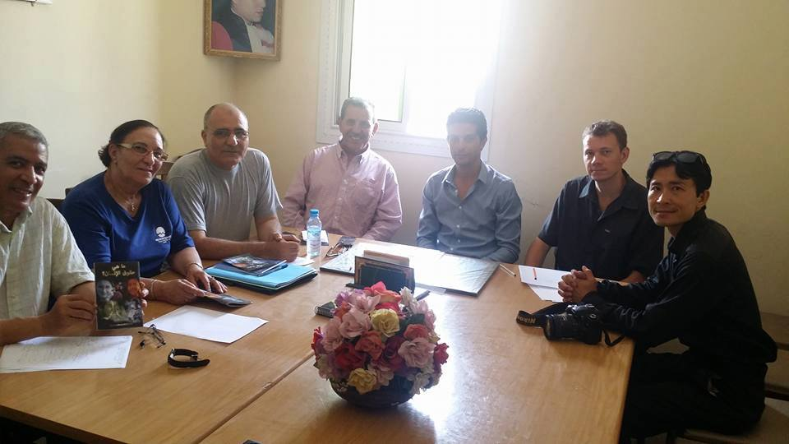
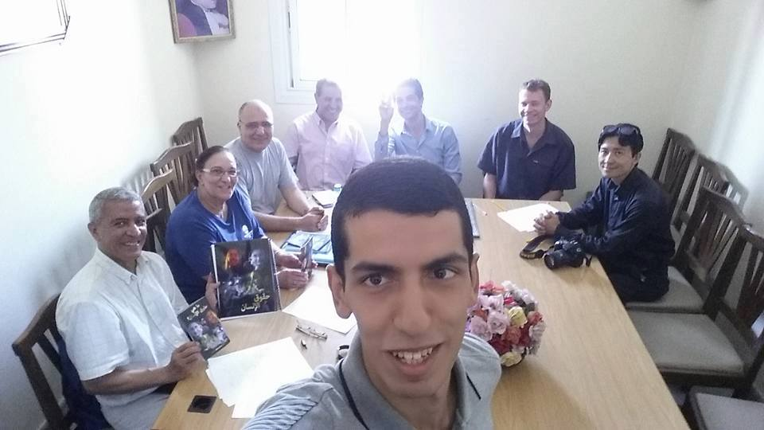
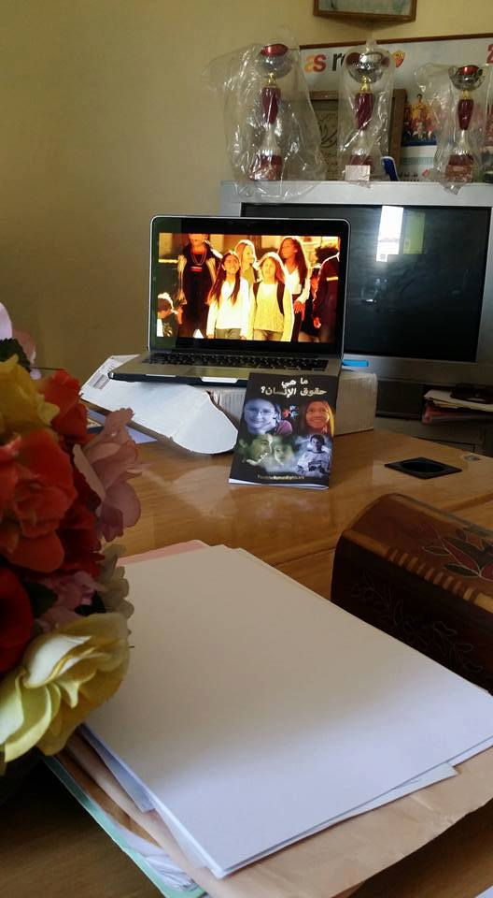

Sekkak Fatima , a teacher by profession , holds a BA Political Science, active member in several national and international associations , president of the Association Atawassol taqafi wa tarbaoui Moab Bnou Jabal ; member of the Moroccan network of the Anna Lindh Foundation , Assistant Secretary of AFDC Association , vice president of the Moroccan Observatory of Education,

specialist in family education and listening and dialogue in schools and in listening observatories, all my activities are addressing education for citizenship, intercultural dialogue , the issue of women.

board member of EA, representative Jossour to Associative Space

adherent since Jossour 97 , director of the Centre for Literacy Counsel of the Association of 2001/2004 , member of the national office and vice president - Proximity to date.

The president of Moroccan observatory of education El Houssine El Moutawakil hosts the team of YFH in his office and give a short description of his institution and what they do for moroccan education he said that he will works with us when the schools starts in september by creating YFR clubs in every shools in Morocco.
Mr El Houssine El Moutawakil sent a letter of interest to Mr Zakaria El hamel the president of Youth for human rights Internationalin Morocco and thnk him for his effort to make world better place through Human rights and relegious harmony education
Saidia
Saïdia, known as the "Blue Pearl", is a beach in Berkane. It is located in the province Berkane, near the Mediterranean Sea and at the Moroccan-Algierian border. Its 14 km coastline is one of the longest beaches of Morocco and is characterized by its golden sand and Mediterranean climate, making it a popular international tourist destination. It hosts numerous resorts and attractions, including private beach resorts, shopping malls, golf courses, and other sports centers.

Saïdia's marina covers an area of 290,000 square meters, with 740 berths and modern marina facilities. (Berthing fees begin at €375 per year.) Tourists are attracted by its traditional folk music festival every August. It is surrounded by a natural bird preserve of marsh and woodland. Access to the main beach is through a eucalyptus forest.

The nucleus of Saïdia dates from 1883 and was the work of Sultan Hassan I, who built a 15,600-square-meter casbah (fortress) on the left bank of the mouth of the river Kiss. Its purpose was to monitor and regulate the movement of people to and from Algeria, which was then under French sovereignty. After Morocco became a French protectorate in 1913, Saïdia proved popular with French settlers and became a resort. After Moroccan independence, Saïdia continued to attract visitors and has become one of the country's most popular tourist attractions.

Saidia
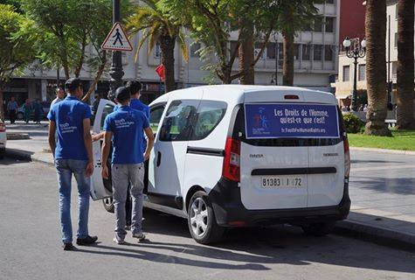
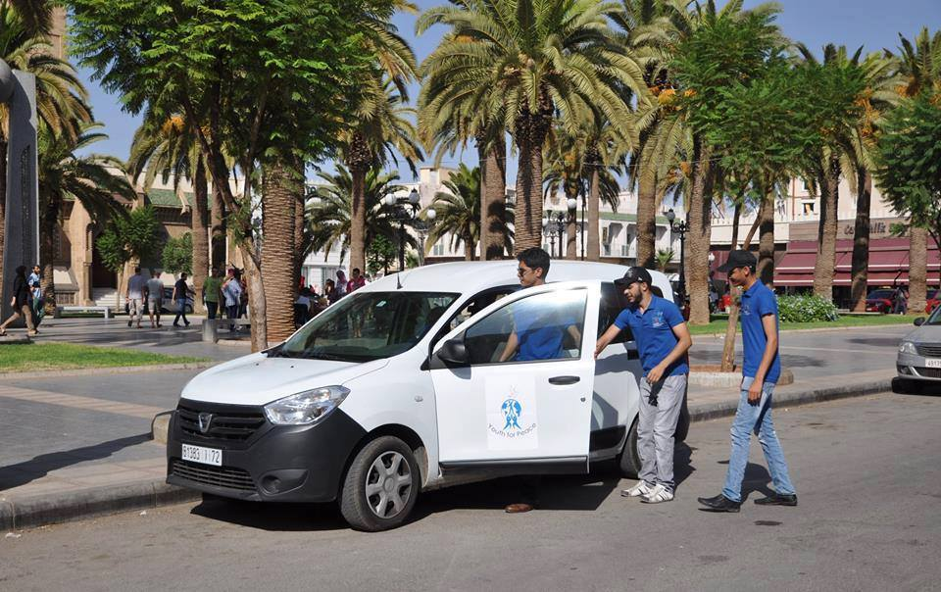
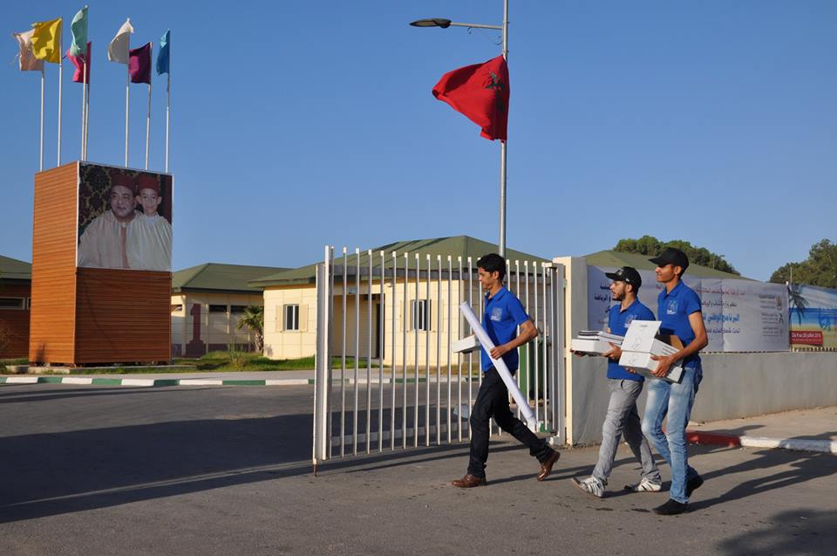
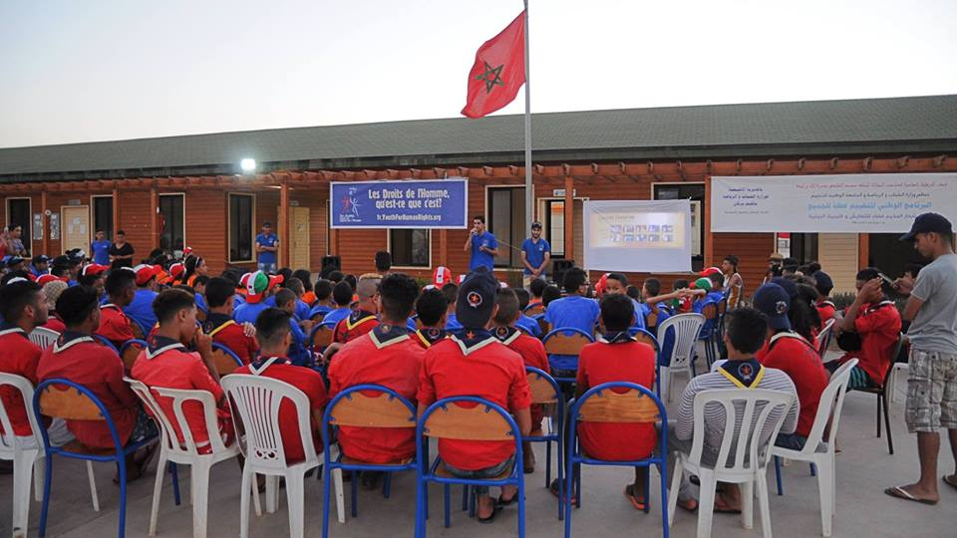
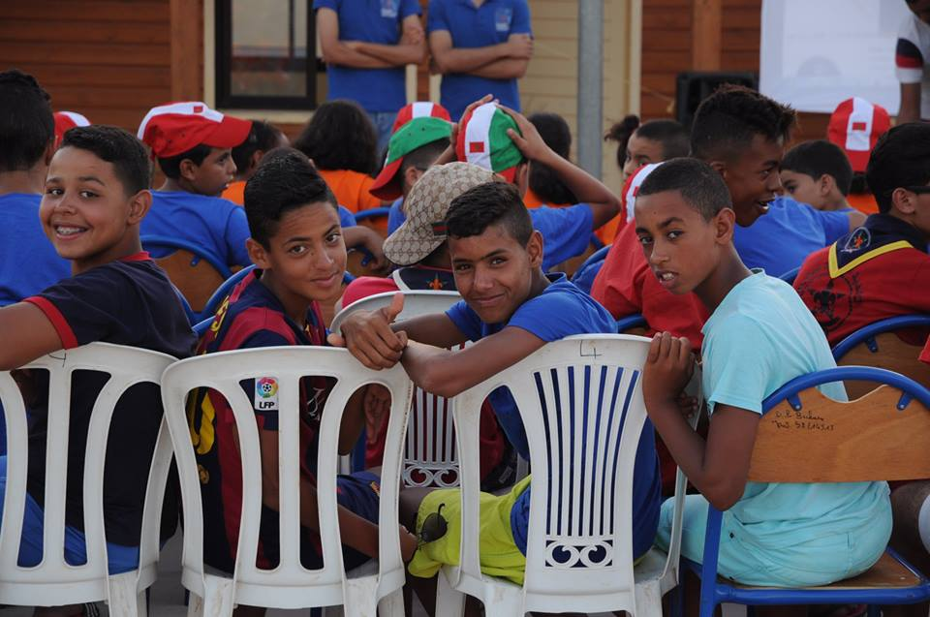
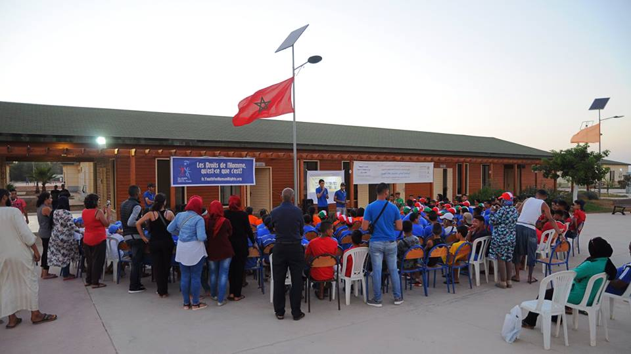
Youth Camp
sponsored by the ministry of youth and sport, Space to accommodate one or more groups of children or young people usually away from their respective homes in a site with a place of accommodation , to offer them activities they have previously choisies.The Camp host more than 1200 kids during the summer.
Youth from all cities in Morocco come to this camp:Rabat.Casablanca.Fes.South of Morocco Tangiers.Agadir
Mr Mohammed el ouardi the director of the camp and his staff Loubna aissaoui and Nada Fadil were so amazing with the YFH team one they arrived to the camp.
Chourouk national association,Moroccan scouts,Maouahib national organization,Youth development Meeting association,

Mr Mohammed El ouardi said that he got his degree in human rights. for him Young People Have the Power to Change the World,they are the future, I welcome hearing your ideas on how we harness the vitality of young people to create a world where everyone counts.
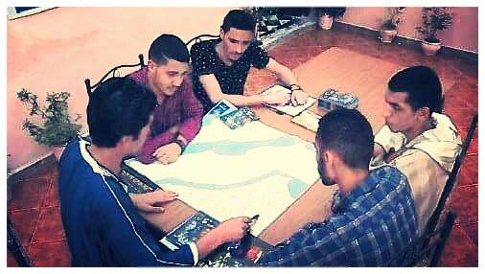
"The journey of a thousand miles begins with one step."

