CALGARY SHINES LIGHT ON INTERFAITH COLLABORATION

City to celebrate its first UN World Interfaith Harmony Week, February 1-7, 2017
Jennifer Neutel
- Community Champions
- and Events
- and Faith-Friendly
January 19, 2017
- Calgary Interfaith Council
Rabbi Shaul Osadchey is on the Calgary Interfaith Council steering committee and approached Calgary’s mayor, Naheed Nenshi, who issued a proclamation to support the week. Various faith communities in the city are collaborating on special programs and events during the Feb. 1 to 7 celebration.
There is already a high and accelerating level of interfaith connectedness in Calgary, Osadchey says. In addition to illustrating the strength of relations and dialogue between various faith communities, Interfaith Harmony Week activities will show that together the faith groups can make positive community changes.
“There is an interest among the different traditions of building bridges, of cooperating together and fostering harmony — which is the word of the week — in ways that strengthen everyone and minimize the intolerance and ignorance people have about religion and its role in civic life,” Osadchey says.
An Opening Ceremony at City Hall at 6:00 PM on Feb. 1 includes the launch of a newly amalgamated Calgary Interfaith Council as the central organization for interfaith activities across the city. The new council will have greater capacity to run dialogues between the different faiths, promote educational programs and social justice efforts, facilitate interfaith worship services, as well as host virtual and in-person tours of religious spaces.
Open houses and pulpit exchanges at houses of worship are planned throughout the week to enhance understanding of various religious traditions, including a daybreak contemplative service that embraces silence. Participants can use a passport for the week and receive a stamp when they visit a house of worship.
“We are very inclusive and hoping people get a broad appreciation of the richness of the religious traditions that bless our city,” Osadchey says.
A breakfast event (Feb. 2) features the theme of multi-faith families and how congregations navigate a family with two faiths.
On Feb. 6 a workshop will explore how congregations and community associations might serve as a community hub for service activities and a safe meeting centre. There is a vision to connect community hubs across the city together to help people better know their neighbours and create stronger quality of life in their neighbourhoods.
NewScoop is hosting a Story Circles event (also Feb. 6) engaging the community to share how their faith communities contribute to Calgary as part of a 50 Stories of Faith project.
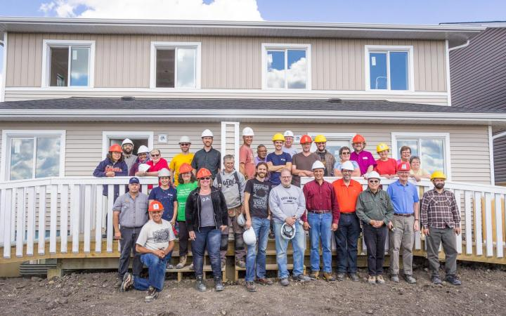
An interfaith clergy build day took place Aug. 24, 2016 in Calgary.

There are two days of work on a Habitat for Humanity Interfaith Build project – a million-dollar commitment to build 10 units of affordable housing. An interfaith build day held in August with 15 clergy of Muslim, Christian and Jewish faiths was a “great day,” Osadchey says.

An interfaith music concert (Feb. 11 and 12) Building Sacred Bridges will serve as a fundraiser for the project.
Are these the kind of stories your organization has to share?
Join NewScoop as an organizational member and become part of creating the news!
The hope is to continue to build on Interfaith Harmony Week in years to come, Osadchey says.
To learn more and register for the events, visit here.

