UPF Austria, Vienna International Centre (United Nations), January 27th 2017: Commemorating World Interfaith Harmony Week 2017, the Universal Peace Federation (UPF) organized a conference on the theme of "Toward Peace and Reconciliation in Conflict Zones - The Role of Religions". The conference was attended by 200 participants including UN diplomats, religious leaders, NGO representatives and other members of civil society. This fifth consecutive annual celebration was held in the UN building in Vienna and included partnering organizations of the Women's Federation for World Peace (WFWP), the United Nations Correspondents Association Vienna(UNCAV-Press), the Best of the World Network, and the International Institute for Middle-East and Balkan Studies (IFIMES).

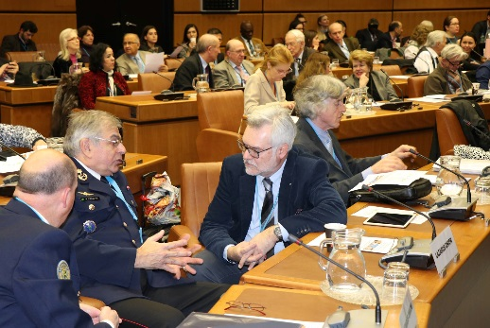 | 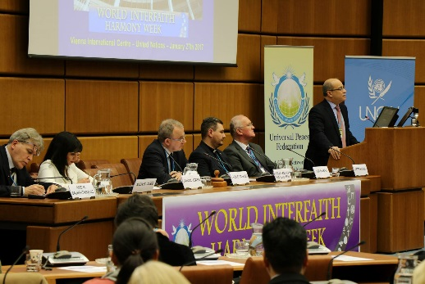 | 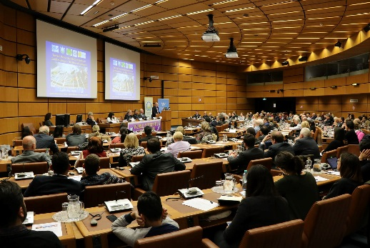

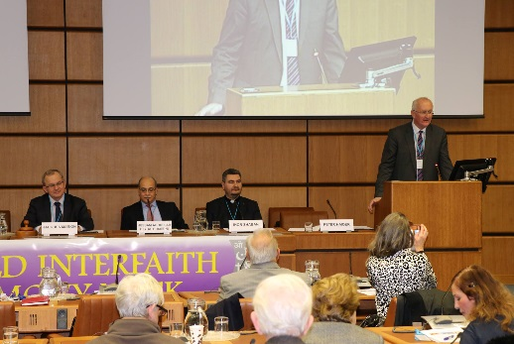 | 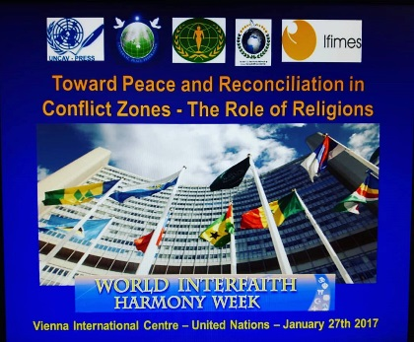 | 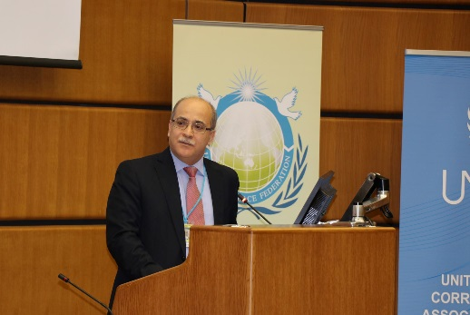

The World Interfaith Harmony Week was first proposed at the UN General Assembly on September 23, 2010 by H.M. King Abdullah II of Jordan. Just under a month later, on October 20, 2010, it was unanimously adopted by the UN and henceforth the first week of February will be observed as a World Interfaith Harmony Week.

UPF and its network of Ambassadors for Peace celebrate this week each year, in a way that encourages understanding, respect, and cooperation among people of all faiths for the well-being of our communities and peace in the world. In his welcome address Mr. Peter Haider, President of UPF in Austria stated that peace can be fully accomplished only when the wisdom and efforts of religious leaders, who represent the internal concerns of the mind and conscience, work cooperatively and respectfully with government officials who have much practical wisdom and worldly experience. UPF advocates for the establishment of an Interfaith Council at the United Nations as well as on national and local levels to provide structures for this to take place. A video of the World Interfaith Harmony Week anthem, "The Gift of Love", as sung by Sami Yusuf, was shown.

The first session, moderated by UPF-Europe Secretary General Jacques Marion, was opened by HE Hussam Abdullah Al Husseini, Ambassador of Jordan to Austria. Reminding the audience that the Interfaith Harmony Week had been initiated by HM King Abdullah of Jordan at the UN in September 2010, Amb. Al Husseini then spoke about the role of religions in peacebuilding, emphasizing that interreligious harmony was an unavoidable condition for peace in the world.

Rev. Dr Ihor Shaban, chairman of the Commission on Ecumenical and Interreligious Affairs of the Ukrainian Greek-Catholic Church, spoke about the stabilizing role of the Greek Catholic Church in his war-torn country; he also described the challenges experienced by Ukrainians in the face of the divisive pressure exerted by their powerful neighbour, and the tensions it caused among Orthodox Churches in the region.

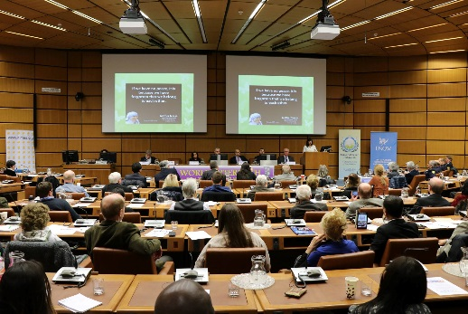

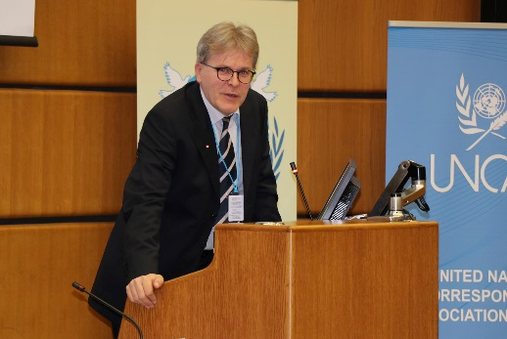 |  | 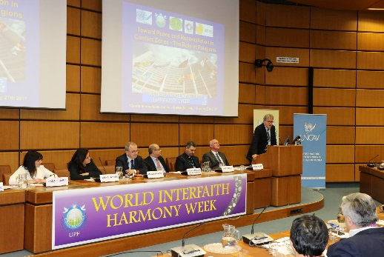

Next, Ms. Lama Al Atassi, a Syrian political activist based in France, involved since 2011 in Syrian opposition activities, shared her expectation for her country to overcome internal divisions by focusing on the recognition of Syrian cultural diversity, and promoting its development within the framework of “secularity” in Syria. She called for reconciliation and peace to promote understanding among ethnic groups while highlighting equality.

Linking justice to both religion and peace, Ms. Nada El Jarid, Political and Cultural Advisor at the Permanent Mission of the Kingdom of Morocco to the UN in Vienna, gave a brief overview of her country’s religious and cultural diversity. She emphasized the importance of combining the efforts of religious leaders with those of national political leaders - and asserted that peace is possible when people are considered not only as a political, economic and social beings but also as spiritual entities.

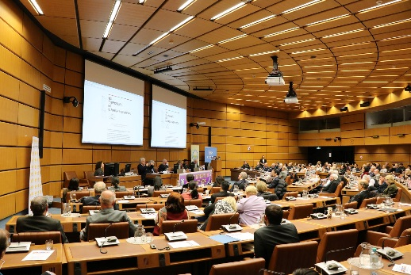 | 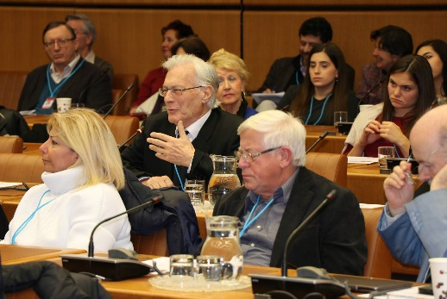

Professor Anis Bajraktarevic, an expert of International Law and Global Political Studies and the IFIMES Representative in Vienna, concluded the session with an assessment of the political and religious interplay in Europe and the Middle East. He warned against trading freedom for security. Noting that peace requires much more than the absence of war, he called for meetings of culture and dialogue.

The second session was chaired by Ms. Heather Wokusch, Liaison Officer for ACUNS Vienna. Opening speaker, Mr. Mayank Sharma, Counselor in the Embassy of India in Vienna, echoed the sentiment that true peace requires more than absence of conflict. He called for the development of structures and tools which reinforce peace and warned of the dangers of simplification in conflict.

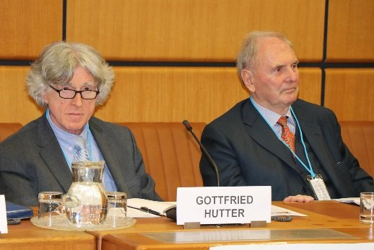 | 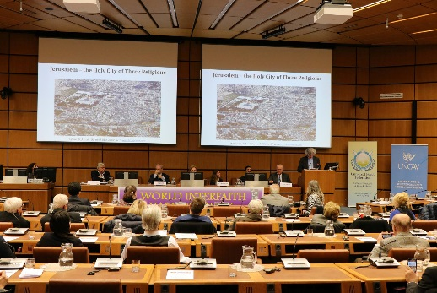

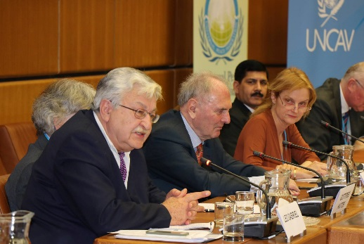 |  | 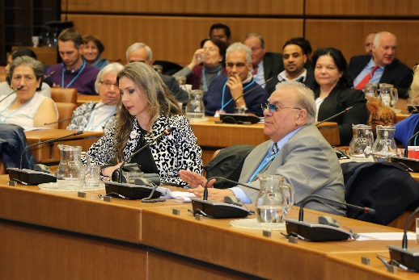

In an upbeat presentation, Dr. Wendelin Ettmayer, former member of the Austrian Parliament and ambassador to Finland, Canada and the Council of Europe, asserted that the logic of war had been replaced by the logic of peace in European states. He insisted that when war is an integral part of the political system, fundamental systemic changes must take place in order to achieve lasting peace.

A spotlight on the practice of dance arts as a tool for the cultivation of spirituality was provided by Ms. Tatjana Sehic MA, program director of the Institute for Cultural Diplomacy in Berlin. After presenting two examples of her art work, she concluded with a video trailer of a dance initiative for a "public tribute and ritual for peace" regarding September 11th.

 | 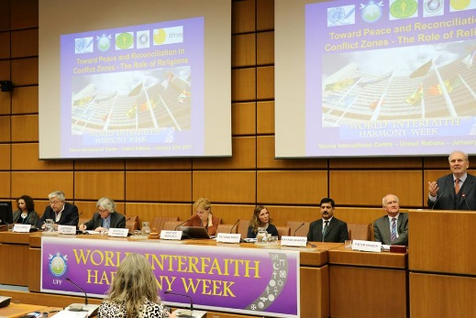 | 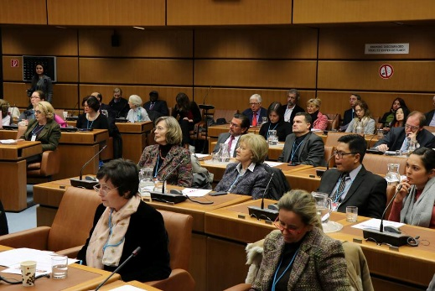

Dr. Gottfried Hutter, a theologian and psychotherapist from Munich in Germany, invoked Martin Luther King Jr. in describing his own dream of creating lasting peace in the Middle East. He saw reconciliation as possible by understanding the 'story' of one's counterpart, expressing regret, and asking for compassion.

Describing his own peace initiative, Dr. Leo Gabriel, a social anthropologist and journalist, noted that religions are not inherently peaceful. As the initiator of peaceinsyria.org, he described the significant efforts which had gone into creating multilateral discussions which eventually had led to the Final Declaration of the Conference on a 'Future Syrian Constitution.'

In closing the conference, Mr. Peter Haider noted that this age of globalization needs enlightened people in each faith, who can examine their sacred writings and traditions and identify aspects benefiting all of humanity as well as those preserving each religion's identity.

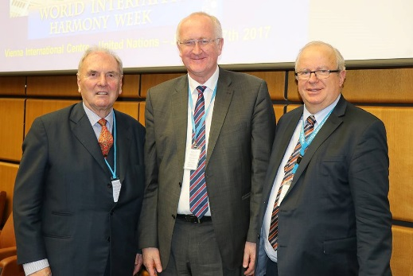 | 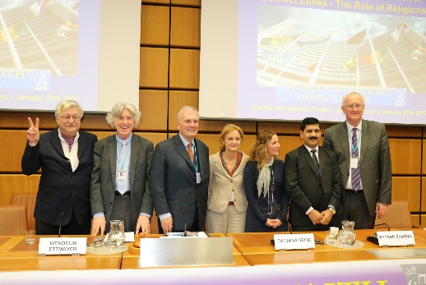 | 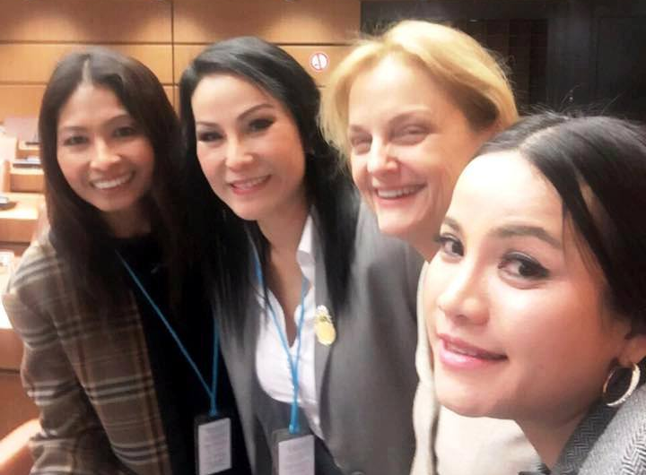

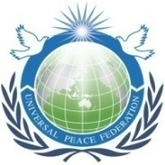
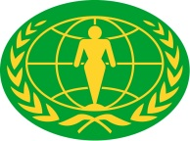

Universal Peace Federation - United Nations Correspondents Association Vienna – The Best of the World Network - Women's Federation for World Peace - International Institute for Middle-East and Balkan studies

Further Information: Peter Haider, Tel.: 0650 2588846

UPF is an NGO in Special Consultative Status with the ECOSOC of the United Nations
________________________________________________________________________________________________________________________________________________________________________________________________________________________________________________________________________________________________________________________________________________________________________________________________________________________________________________________________
Seidengasse 28/4, 1070 Wien, Austria; ZVR: 182012940; E-Mail: info@weltfriede.at

