World Interfaith Harmony Week Event 5 February 2017

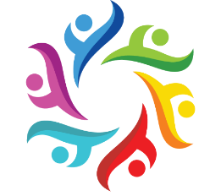

In honour of the United Nations' World Interfaith Harmony Week, the first week of February, UVic’s Multi-Faith Services and the Victoria Multifaith Society are joining together to present

Healing the World:
Appreciating Diversity, Creating Community

A panel of local leaders from 8 world faiths will discuss the tools & spiritual teachings that are most needed for humanity to heal and flourish.

Join us for a joyful and informative afternoon celebrating interfaith harmony through the arts, song and social discourse!

The event will open with displays and refreshments at 1:00 p.m., with the program following from 1:30 - 4:00 p.m.

Sunday, 5 February, 2017
David Lam Auditorium
Maclaurin Building A144
University of Victoria

Free parking on Sundays.

Sponsored by UVic's Multi-Faith Services and the Victoria Multifaith Society

For further information, contact Sheila Flood, 250-818-9099.

Facebook event page with poster.

