Celebration of World Interfaith Harmony Week, 2017
Date: 5/2/2017
Venue: Anwar Shaheed Colony Renala Khurd Okara Punjab,Pakistan
Organized by: COPE Pakistan CC
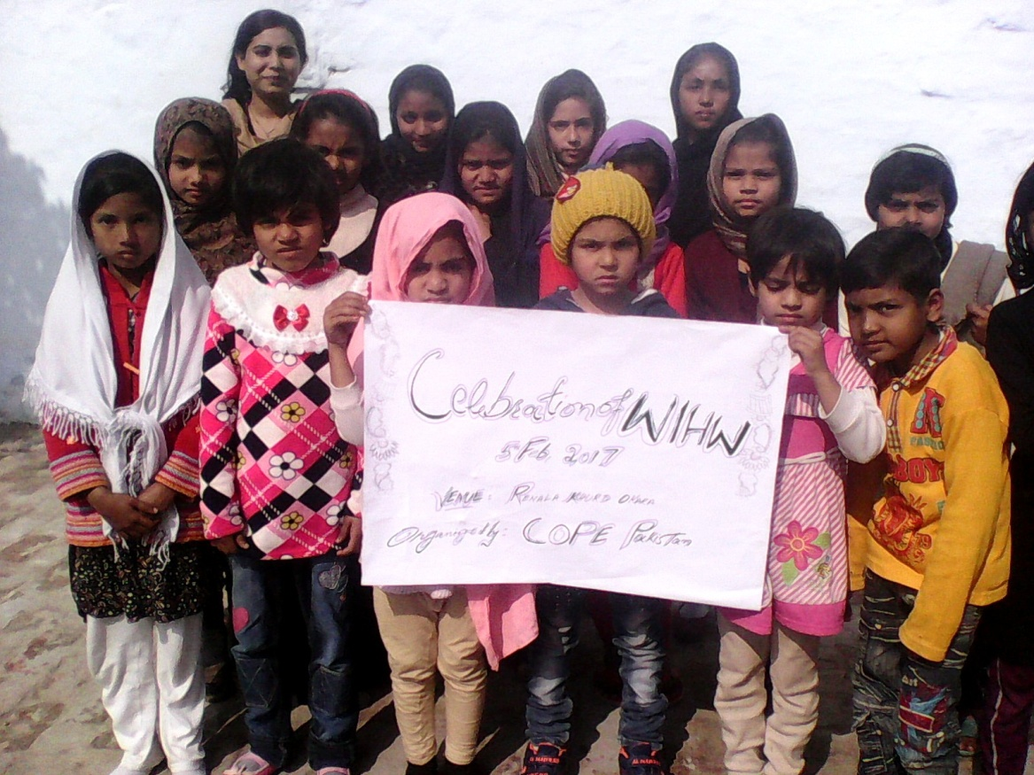

COPE Pakistan CC celebrated World Interfaith Harmony Week on 5th February,2017 at Anwar Shaheed Colony Renala Khurd with the children from different regions as Muslims and Christian. Mr.Asher Nazir cc coordinator of COPE Pakistan welcomed to all children and talked on WIHW. He said that as a human we should promote peace and harmony among all religions. All Children from all religions is the future of Nation and you are the seeds you peace and in coming days you will be a big and strong tree of Peace and harmony in the World.
Teachers and students of Sunday school and Coaching Center made colorful charts with positive images and symbols and sharing in groups on peace and harmony. They said that we are the beautiful creation of Lord and we can play our positive role in our family, Friends, School and in our society to promote peace and interfaith harmony.
Mr.Asher Nazir thanked to all children and appreciated them for their wonderful participation and sharing in the celebration of World Interfaith Harmony Week 2017.

