Ref No.:: RHF.2016.03.01 Date: Saturday, 5 March, 2016
To,
The President,
Royal Islamic Strategic Studies Centre
20 Sa'ed Bino Road, Dabuq
PO BOX 950361
Amman 11195
Jordan
Subject:: Religious Harmony Foundation and Aruna Manharlal Shah Institute of Management & Research jointly Celebrate “The World Interfaith Harmony Week 2016” By conducting 10 events to promote interfaith harmony
Dear Sir,
Religious Harmony Foundation is a public charitable trust based in Mumbai – INDIA whose aim is to strive to bring religious harmony and promote interfaith dialogue across the world. Some of the key objectives of the Trust are:
1. To conduct lectures across the world on the need of religious harmony as the key ingredient of world peace.
2. To organize essay, painting, slogan, quiz and other events for the propagation of religious harmony.
3. To promote interfaith harmony through audio-visual media like films.
4. To reward the people who have done exemplary work to bring religious harmony in the society.
5. To work closely with religious and political leaders to bring peace in the world through interfaith harmony.
6. To undertake any and every activity for the interfaith promotion so as to bring permanent peace in the world so that we may achieve prosperity
Aruna Manharlal Shah Institute of Management & Research is a leading management institute in Mumbai, INDIA imparting world class management education.
Religious Harmony Foundation and Aruna Manharlal Shah Institute of Management & Research support the “The World Interfaith Harmony Week” and decided to celebrate the same jointly.
A total of 10 events were conducted from 1 – 7 February, 2016 to celebrate “The World Interfaith Harmony Week 2016” to give the message of religious harmony, interfaith and peace.
DAY1 (Monday, 1 February, 2016)
Event 1: Inauguration and lecture on ‘Religious Harmony – The key to world peace’
The World Interfaith Harmony Week 2016 was inaugurated by reading out the United Nations resolution to celebrate The World Interfaith Harmony Week in the first week of February. After this the lecture on ‘Religious Harmony – The key to world peace’ was by conducted Mr. Manish Tripathi which was vibrant and vivacious. This lecture has four parts: 1- What is religion and its role in the world? 2- Short description of world leading Religions in Alphabetical order 3- Need of Religious Harmony 4- How to Achieve Religious Harmony 5- Role of Government, political leaders, religious leaders and the people. He excited everyone by asking some questions on peace and giving away prizes. This lecture gave the message of peace and harmony.
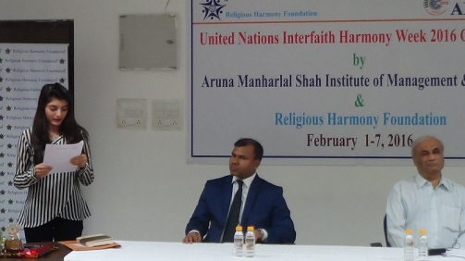 | 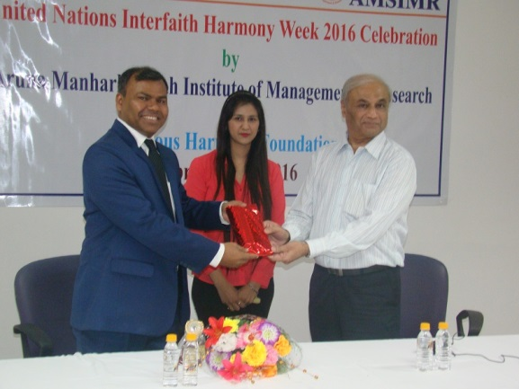
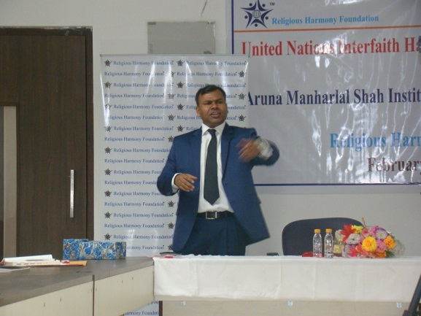 | 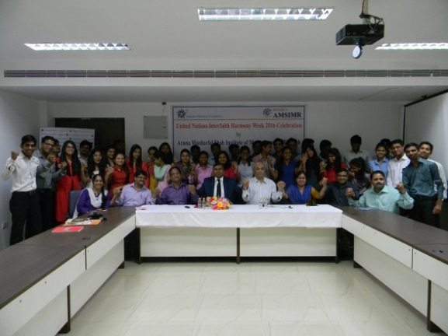
DAY2 (Tuesday, 2 February, 2016)
Event 2: Essay writing and speech competition on topic “ Religious Harmony – The key to world peace”
An Essay Competition was organized and 24 students participated on the topic - “Religious Harmony: A Key to World Peace”. Three best essays were awarded trophies and certificates were given to all participants. There was a Speech Competition organized for the students. Five students namely; Neha Khan, Sagar Guntukula, Suhas Waman, Swapnali Desai and Vijay Sharma spoke on the subject of Religious harmony and their performances were jointly adjudged by Dr. Irfan Engineer ( The chief guest at the occasion) and Mr. Manish Tripathi. The winners in order were: Swapnali Desai, Sagar Guntukula and Neha Khan.
Thereafter, Dr. Irfan addressed the audience and his speech and ideologies were very scintillating and knowledgeable. He electrified the audience by reciting Dohas of Sant Kabir and others and explaining their meaning.
Through this event, the need of religious harmony for bringing sustained peace in the world was highlighted.

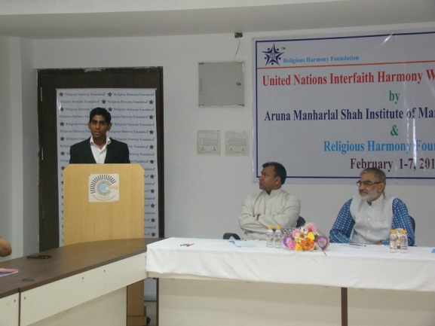 | 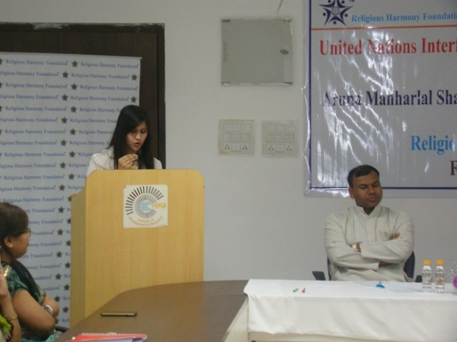
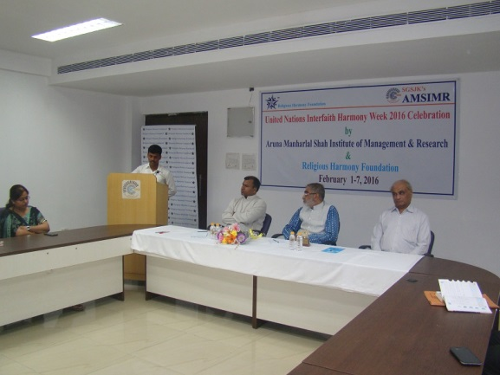 | 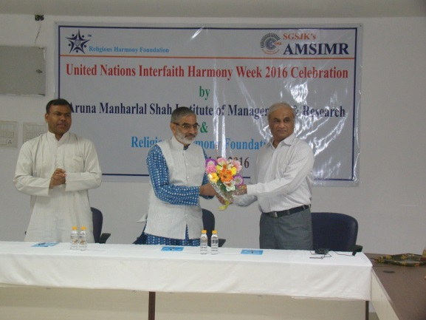

DAY3 (Wednesday, 3 February, 2016)
Event 3: Management contest on topic “Religious Harmony for the progress of the Nation”
A management Presentation Competition was organized for our students on the topic – “Religious Harmony: A Tool for the Progress of Nations”. Five of the students namely; Drishti Tank, Gaurav Boricha, Navin Kesharwani, Pooja Mahadik and Rohit Palwankar made excellent presentations with their ideas and style. The performances were judged by Dr. Ram Puniyani (The chief guest at the occasion)) and Mr. Manish Tripathi. The Winners were: Pooja Mahadik, Drishti Tank and Navin Kesharwani in an ascending order.
Later, the Chief Guest enthralled the audience his knowledge in History and clarified number of wrong notions. He was a History book himself. Dr. Ram Puniyani requested everyone to remove religious bias from there mind and to live together in harmony.
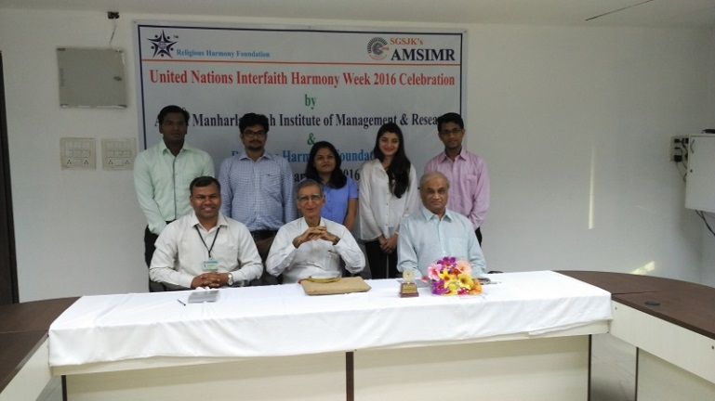 | 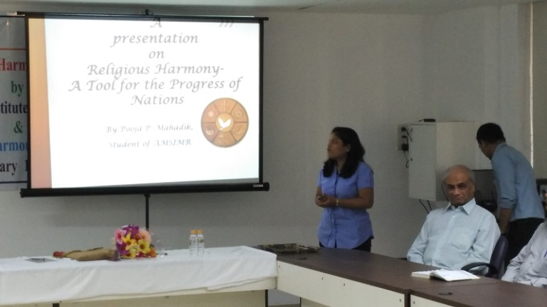
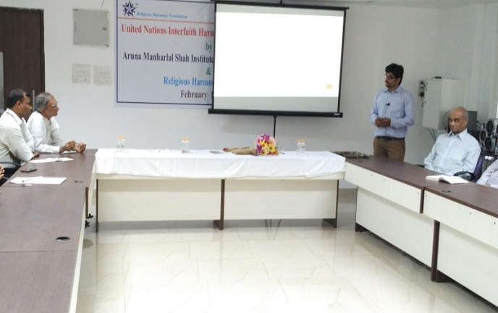 | 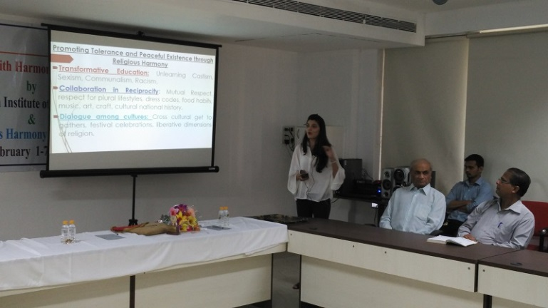

DAY3 (Wednesday, 3 February, 2016)
Event 4: Painting competition with school children on topic “Religious Harmony for National Integration” at SVDD High School
A Painting Competition was organised at Sheth Virchand Devji Dhanji English Medium High School (SVDD), Ghatkopar (E) on the topic “Religious Harmony for National Integration” . 96 students participated and each of the students did fabulous drawing and painting work to mesmerize us all. Mrs. Tiny Fernandez (Principal) and her drawing teachers namely; Ms. Chhaya Thakkar and Ms. Stuti Mistry were supportive and made necessary arrangements to organize the event.
These paintings give a message of peace and harmony. There is plan to showcase these paintings across the globe to promote interfaith harmony.
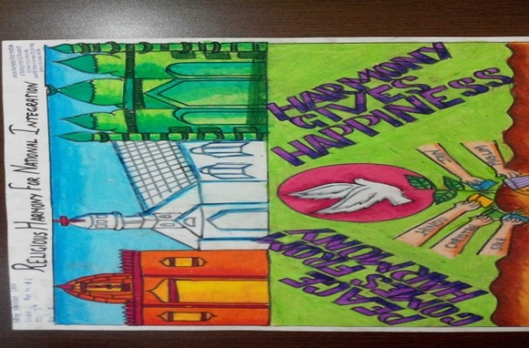 | 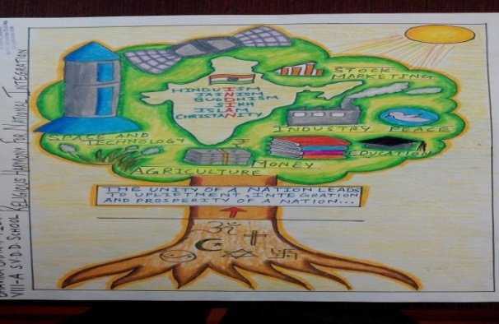
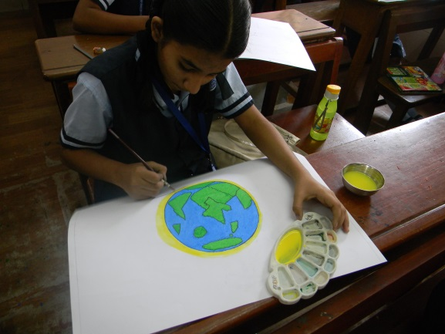 | 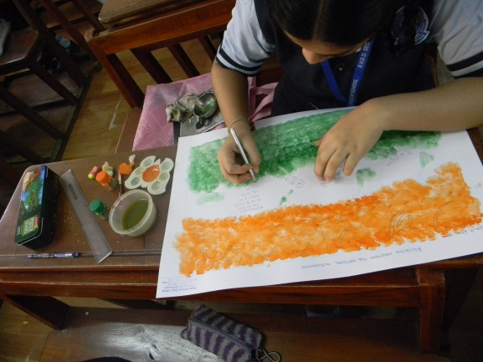

DAY4 (Thursday, 4 February, 2016)
Event 5:Release of Hindi documentary film on Religious Harmony
A Hindi (a language spoken by more than 1 billion Indians) film on ‘Religious Harmony’ was released. This film explained in the detail about the need for religious harmony and how to achieve it. Later students were asked general knowledge questions about religious harmony and given prizes.
This film will be promoted online on social media to reach out to masses and create the need for the interfaith harmony.
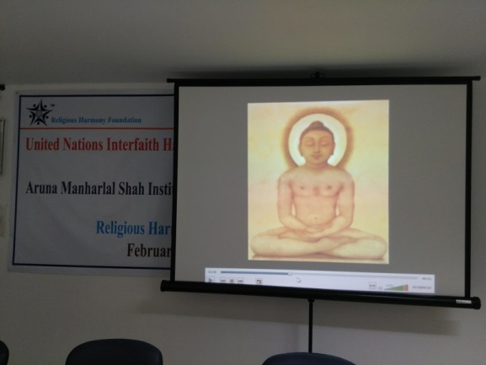 | 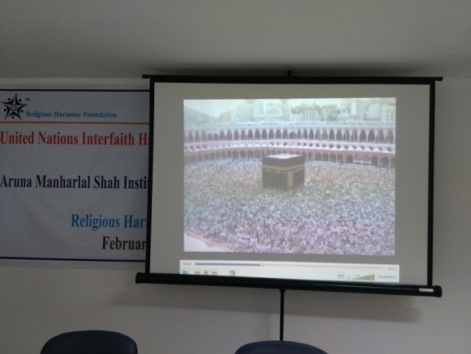
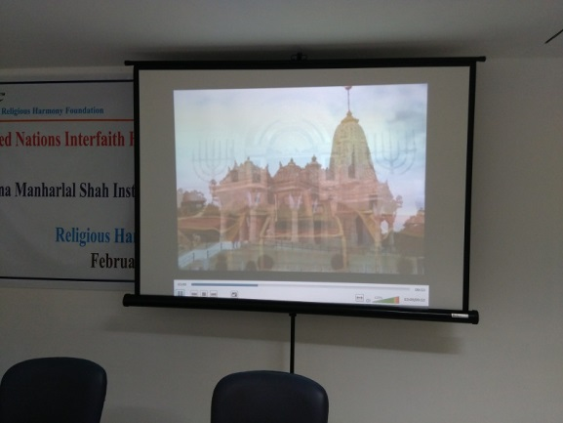 | 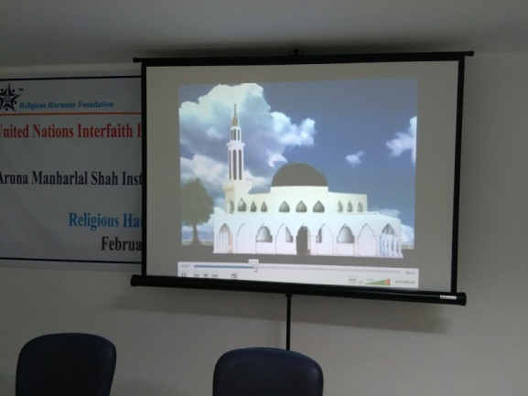

DAY4 (Thursday, 4 February, 2016)
Event6: Panel discussion on topic “ Peace – A prerequisite for the nation’s growth”
A Panel Discussion on the topic “Religious Harmony: A Pre-requisite for Nation Building” was organized. The professors from the institute participated and expressed their detailed and analytical view on peace building in the world. The panel members were: Prof. Sandeep Kudtarkar, Prof. Saumali Bose, Prof. Bharat Vir and Prof. Pankaj Kulkarni. The moderator for the panel discussion was Mr. Manish Tripathi. All spoke at length bringing their philosophies and thus put up a good show.
This panel discussion created an intellectual base for the promotion of religious harmony. It created the need for religious harmony in logical manner and shared it benefits.
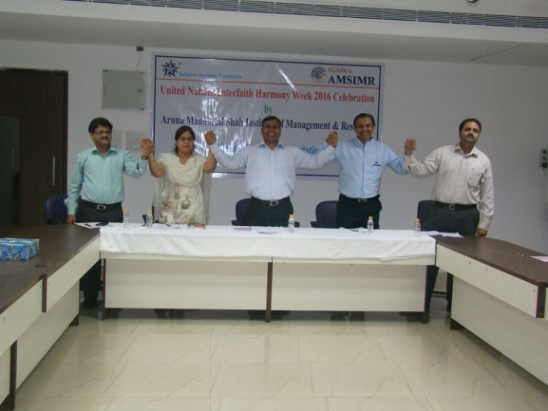 | 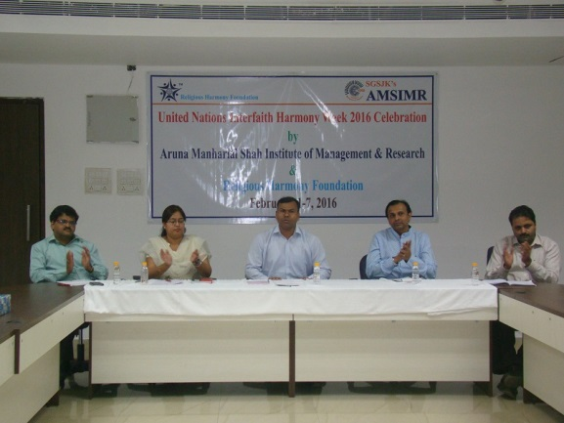
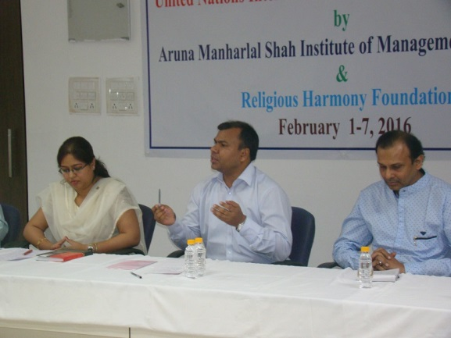 | 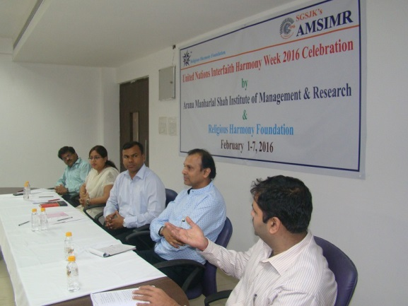

DAY5 (Friday, 5 February, 2016)
Event 7: Release of Marathi film on Religious Harmony
A Marathi (a language spoken by about 115 million Indians) film on ‘Religious Harmony’ was released at Maheshwari Vidyalaya and Jr. College. Around 400 students and teachers were present. Some of the teachers spoke on the subject of ‘Religious Harmony’. Later students were asked general knowledge questions related to the subject and were awarded with gifts. Mrs. Anjali Kotiyal (Principal), Ms. Roshani Khonde (H M of English Primary Section) and Ms. Uma Maheshwari were very cooperative and rendered necessary support.

This film gives a detailed insight onto the topic of religious harmony and has ability to root out the religious intolerance from the heart and mind of people. This film will be promoted throughout India. Later on this film will be produced in English and promoted across the globe.

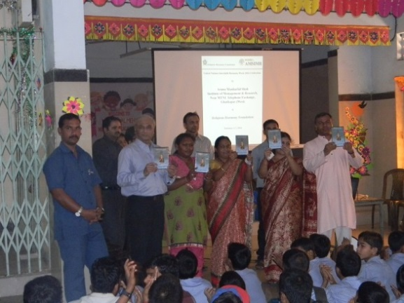 | 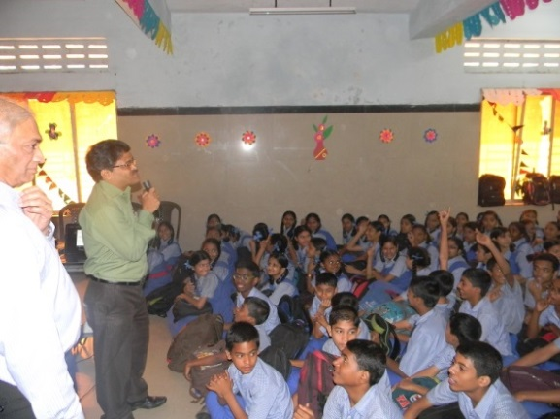
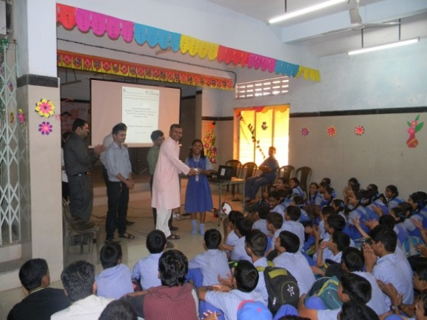 | 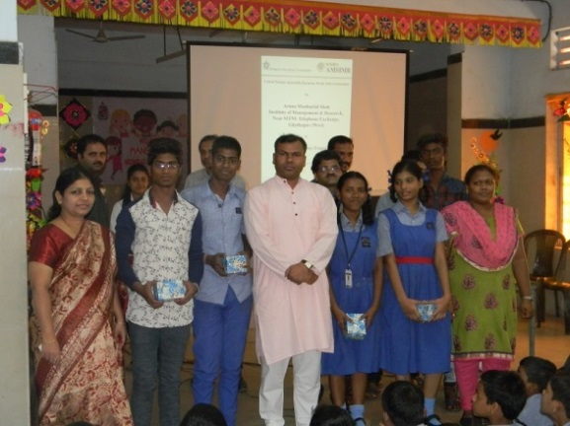

DAY5 (Friday, 5 February, 2016)
Event 8: Painting competition with school children on topic “Religious Harmony for National Integration” at Fatima High school
A Painting Competition was organized at Fatima High School, Ghatkopar (W). 40 students participated and drew excellently giving wonderful and matured messages. Fr. Philip Gonsalves (Principal), Fr. Albert Gonsalves and drawing teacher Ms. Sadhana Chaughule gave us the necessary support to organize the event.
These paintings give a message of peace and harmony. There is plan to showcase these paintings across the globe to promote interfaith harmony.
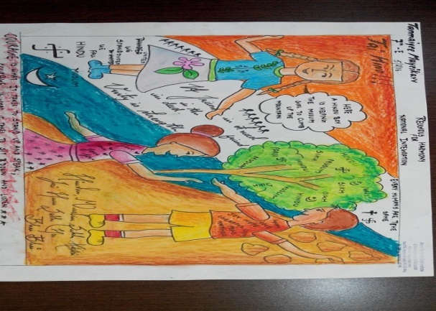 | 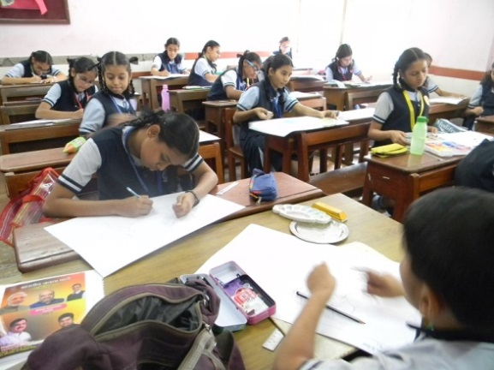
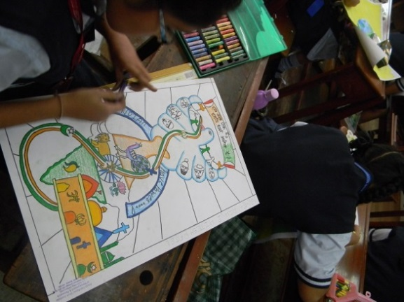 | 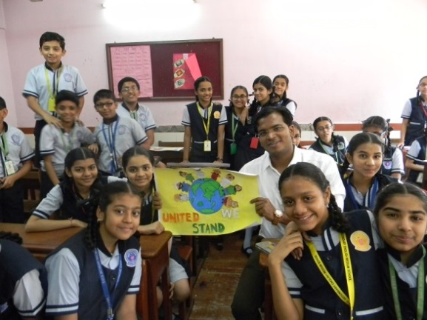

DAY6 (Saturday, 6 February, 2016)
Event9: Screening of Marathi film on Religious Harmony among the MBA students
The Marathi film on ‘Religious Harmony’ was showcased for the benefit of the students and invitees. This film was show to management students who will lead companies in future and become brans ambassadors of interfaith harmony.

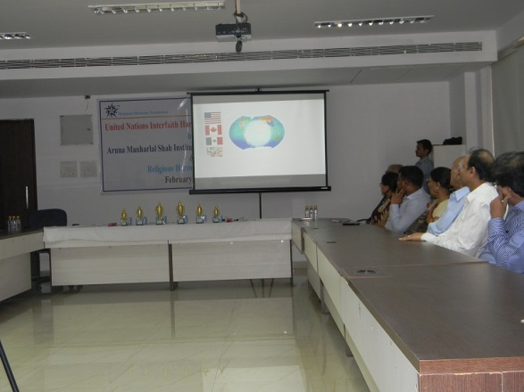 | 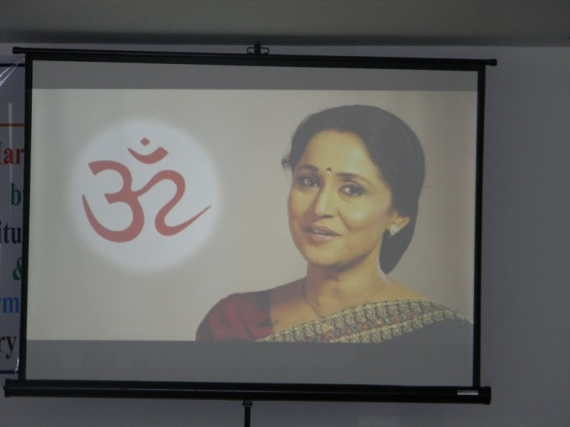
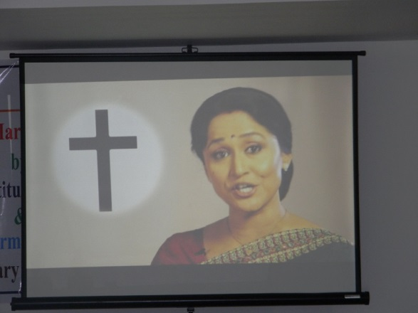 | 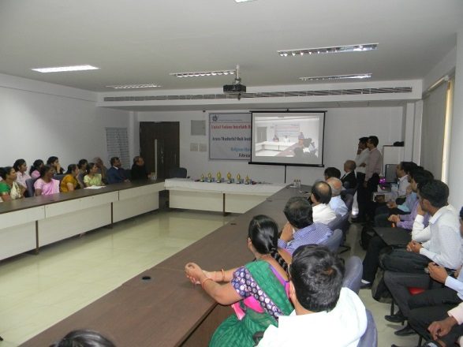

DAY6 (Saturday, 6 February, 2016)
Event 10: Interfaith Medical camp and Valedictory function
The Valedictory function was celebrated by inviting Dr. Narendra Kumar (a renowned cardiologist) as the Chief Guest. Parents of the students were also invited to participate in the event. A video was also prepared by Mr. Amit Dhage by highlighting the activities of the previous days.
Then Dr. Narendra Kumar gave health tips to all for a healthy living and answered the questions from the audience. It was followed by prize distribution. All the students who were declared winners were given trophies and gifts. Prof. Saumali Bose proposed vote of thanks to all. It was soon followed by Medical checkup of those enrolled for the same by Dr. Narendra Kumar and his Team.
After this the refreshment was offered to everyone and week-long UN Interfaith Harmony Week 2016 came to an end.
Through this week long events, interfaith harmony week was promoted in every possible way and we feel that this will go a long way in promoting peace in the world. The information and content generated during the week will be a source of great information to the rest of the world and would provide a knowledge base for peace building.

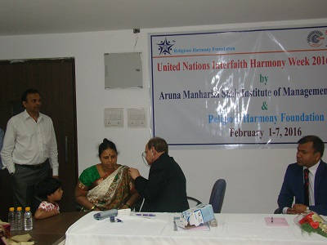 | 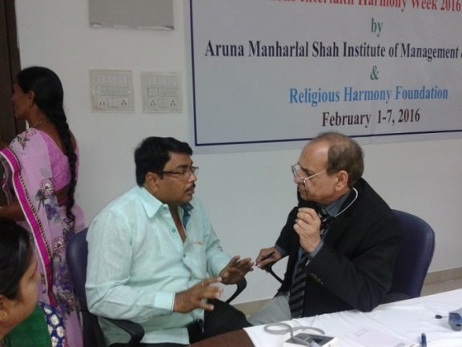
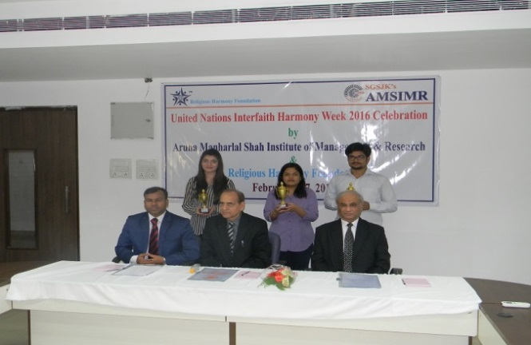 | 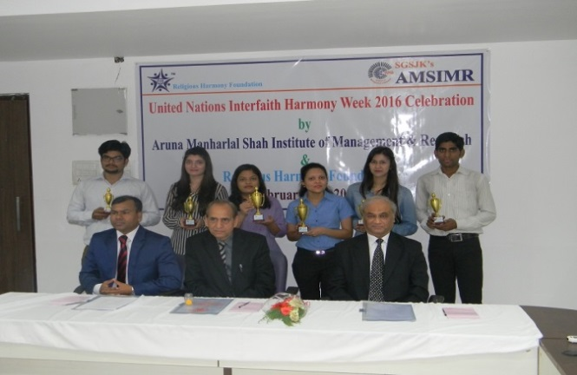

EVENT IN THE NEWS::
The event was widely covered in media and got good attention from public at large. Below is the news article published in a leading business newspaper::
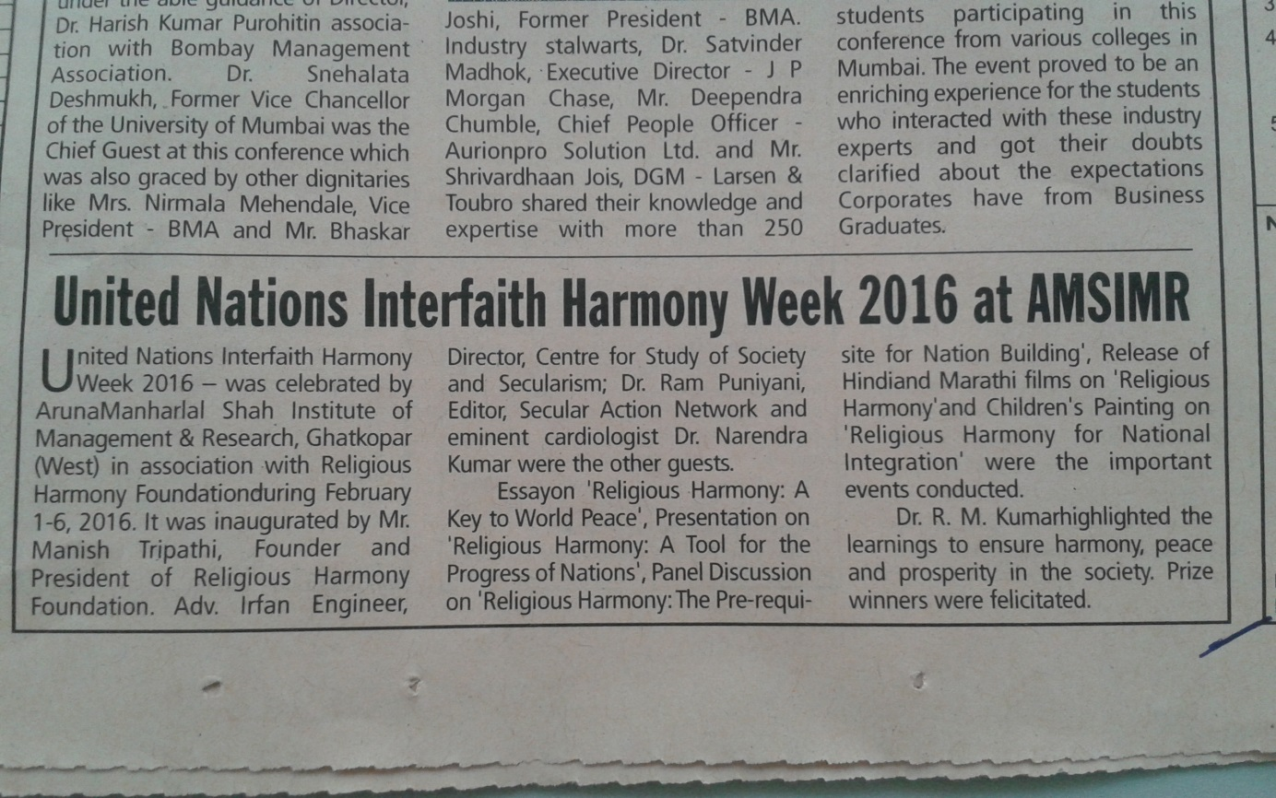

Your Faithfully,
Manish Tripathi  (President)  Religious Harmony Foundation  Mobile: +91-9820711480  E-mail: info@religiousharmony.org | Dr. R. M. Kumar  (Director)  Aruna Manharlal Shah Institute of Management & Research  Mobile: +91-9820458239  E-Mail: rmkumar@amsimr.org
Important Links:
- The location where all other videos related with the event are uploaded (URL: https://www.youtube.com/ReligiousHarmony/)
- The location where all the photos related with the events are uploaded (URL: https://www.facebook.com/ReligiousHarmonyFoundation)
- The link of video showing the all events conducted during the week ( VERY IMPORTANT VIDEO)
https://www.youtube.com/watch?v=MCQnl46g7m0
- The link of video of the speech given by Mr. Manish Tripathi on topic “Religious Harmony – The key to world peace”
https://www.youtube.com/watch?v=lEaFDimgd5E

