The Nishkam Centre Celebrates World Interfaith Harmony Week 2016
Compassion Workshops
Workshops were held on Tuesday 2nd February and Thursday 4th February at the Nishkam Centre, in collaboration with Nishkam Primary School. In these workshops, which were held as part of World Interfaith Harmony Week, Key Stage 1 pupils were guided to explore two of the 24 dispositions: 'Compassion' and 'Being Modest and Listening to Others'. These workshops were designed to begin to help children understand the meaning of the 24 dispositions, as outlined in the Religious Education syllabus. This event marks the start of a broader initiative to develop similar workshops in innovative ways so they can be shared with other schools.
The Nishkam Centre corridors echoed with the sound of excited voices as Key Stage 1 children made their way to the Nishkam Centre Heritage area. Nishkam Primary School was passionate about giving the opportunity to all of the children in that age group and therefore two workshops were held. SACRE (Standing Advisory Council for Religious Education) Members were invited on Thursday’s workshop so they could observe and provide feedback for future workshops in the wider Birmingham school community.
Children rotated between four activities. They created a compassion chain, acted out scenes of compassion, recognised emotions and reconstructed torn paper hearts. Inderjeet Sagoo, who has been a teacher at Nishkam Primary School for 3 years, stated that the activities were very moving. “The compassionate hearts activity started as a mere "draw a heart" exercise but after tearing up their hard work, it turned into an exercise of empathy. The children's reactions showed that, innately, they are empathetic individuals that have a deep rooted value of compassion inside each and every one of them." This activity consisted of one child drawing a heart, while the second child glued it back together after it had been torn.
SACRE members attending Thursday's workshop included William Ozanne, Sue Fearon, Marius Felderhof, Guy Hordern and Ranjit Dhanda, Sewa Singh Mandla - Nishkam Centre Trustee, and Cathy Heels - Head teacher at Nishkam Primary School. All attendees thoroughly enjoyed the workshop and found it very engaging. Guy Hordern stated "the children were lively, chatty, relaxed and 100% engaged with the subject matter".
Some quotes from children during the workshops included;
"If someone is sad I will make them happy."
"I'll do one half, you can do the other."
"We need kindness in the whole world."
"To feel what others are feeling."
The Nishkam Centre will continue to work in collaboration with Nishkam Primary School to initiate workshops, sharing ways of disseminating the meanings of the 24 dispositions to children so they are able to incorporate them in their day to day lives.
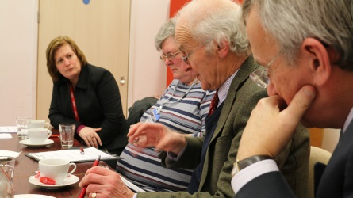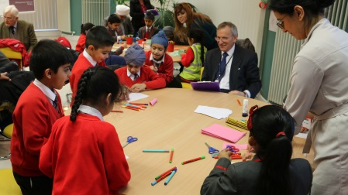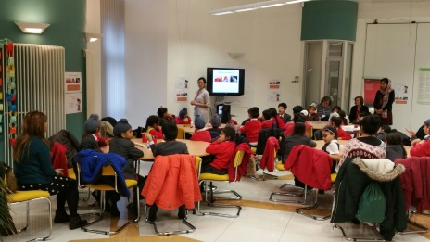
Faith Action – Friendly Places Free Training
On Monday 1st February 2016, the Nishkam Centre and Faith Action hosted a free workshop that focused on steps people of faith can take to make their places of worship more friendly for people living with mental health conditions.
Mental health problems are very common, affecting one in four of us every year. Every faith community contains people who have experienced mental health problems as it does not discriminate and effects people from all backgrounds and faiths and no faith. Faith groups are places of community, meaning and connection, which make them ideal for welcoming and supporting those struggling with their mental health.
Friendly Places is based on the fact that faith and places of worship has the potential to be a huge resource within communities for supporting people, including those who might be struggling with their mental health and wellbeing. It exists to help raise awareness among faith groups of this responsibility. Of course, many groups are doing great things already, so the initiative is also about celebrating the part they are playing, and highlighting this to policy makers and health services.
The two hour workshop covered being a Friendly Place and introduction to the Friendly Places Pledge, exercises such as - what a good welcome does and doesn’t look like, facts and figures about mental illness, action planning – steps that groups could take to become a Friendly Place and an opportunity to network with other attendees.
The focus group was diverse with members from many communities. Some attendees included Narinder Kaur Sidhu – Chaplain at Nishkam Centre, Manir Hussain – Administrator and Chaplain at Qadria Trust in Sparkhill, Matloob Hussain – Faith Leader and Chaplain at Central Mosque Lozells, Jackie Gayle – New Jerusalem Apostolic Church & Chaplain, Abbas Shah - Mimar Organisation and Colin Braham – Rastafarian Faith Advisor and Chaplain.
Narinder Kaur said "the training was well organised and delivered through PowerPoint exploring various scenarios. The group was well informed and all were happy to make the “Friendly Places” pledge for their organisations and places of worship, helping people with mental health issues, providing a listening ear and assisting in their mental wellbeing”.
“All attendees agreed that funding is required when it comes to chaplaincy and emotional wellbeing, and this is an issue that should be addressed. Colin Braham stated that he has witnessed the lack of funding that is set aside for mental health and chaplaincy, as he delivers this service in his community i.e. home visits, funerals, befriending, etc.”
At the end of the presentation, Abbas Shah from the Mimar Organisation invited all attendees to come and visit them at their organisation so he could begin to develop Friendly Places.
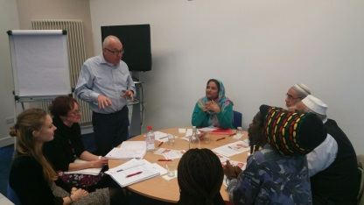
Further training will be provided through Friendly Places, and with this initiative, a higher level of assistance will be available in faith based organisations for people with mental health issues.
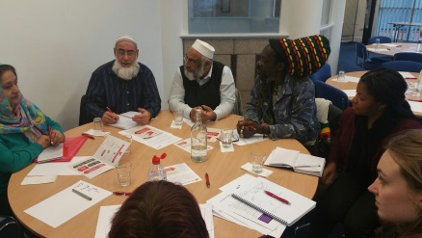
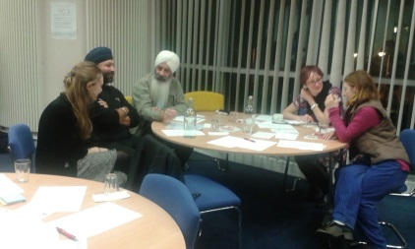

Prayer Walk – Rain or Shine!
On Saturday February 6th, the Nishkam Centre was honoured to host the first monthly Peace & Prayer Walk. There have been 7 Peace & Prayer Walks thus far, and will continue to run on the first Saturday of every month.
The walks began as an initiative by the community to raise awareness and concerns against a spate of recent Knife and Gun Crime in the Handsworth area, many members of the community are committed to ensure this does not become the norm in Handsworth, Hockley, Lozells, and Aston.
It was a cloudy afternoon on Saturday and the rain was relentless. Amongst this gloom, there were individuals determined to spread light and warmth in the community. About 30 members of the community gathered to show their support and participate in the Peace & Prayer Walk despite the rain. They arrived at the Nishkam Centre at 3pm, and after a collective prayer began their march. The route took them up to the Hockley flyover and all the way down to Boulton Road before they made their way back to the Nishkam Centre where light refreshments were then provided with hot cups of coffee and tea.
Members handed out leaflets that read “NO to guns and knives, YES to life” along with the contact information of organisations that provide support with knife and gun related violence, which can be found on the pictures below.
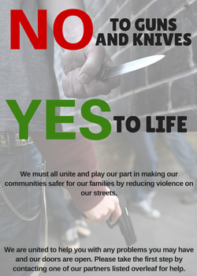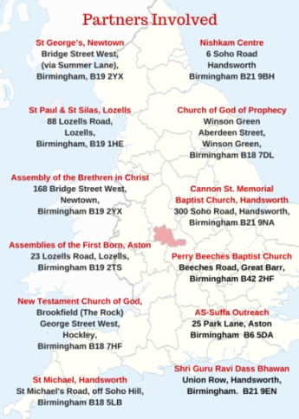
Faith in Birmingham – New Gallery at the BMAG
On Thursday 4th February 2016, staff and volunteers from the Nishkam Centre & Guru Nanak Nishkam Sewak Jatha (GNNSJ) were invited to a private launch of Faith in Birmingham, a new gallery at Birmingham Museum and Art Gallery. Faith in Birmingham explores some of the many faiths that make up Birmingham’s rich and diverse communities.
Volunteers from the Nishkam Centre & GNNSJ and other Sikh organisations contributed to the new gallery through the Steering Group and working group. The working group was established to help shape and inform the direction of the gallery, made up of local individuals who practice one of the six faiths that the gallery will cover it its first year; Christianity, Islam, Buddhism, Hinduism, Sikhism and Judaism.
Members of the community gathered in the magnificent Round Room and mingled whilst they waited for the evening to begin. The atmosphere was welcoming with an air of excitement as attendees wondered what the new gallery would bring. The programme began with a prayer and kirtan (devotional singing) by volunteers from GNNSJ evoking gods blessings for the opening of the event. The devotional shabad (hymn) was one of contemplation. “Do not say that the Vedas, the Bible and the Koran are false. Those who do not contemplate them are false.”
Councillor Penny Holbrook from Birmingham City Council then did a speech welcoming the delegates, and attendees proceeded to make their way to the gallery room.
The free gallery consisted of many pictures and sacred religious objects including the Birmingham Qur’an. It was a great example of interfaith, as the values and beliefs that are mutual across faiths were portrayed through the gallery. It was a collective example of faith reflecting the harmony of faith communities in Birmingham.
The BMAG is open from 10 am to 5 pm daily and this gallery is one that should not be missed!
