Interfaith Conference in Lahore, Pakistan to celebrate World Interfaith Harmony Week 2016
The United Religions Initiate (URI) Pakistan along with another likeminded organization FACES organized a conference in Pakistan to observe and celebrate World Interfaith Harmony Week from 1-7 February.
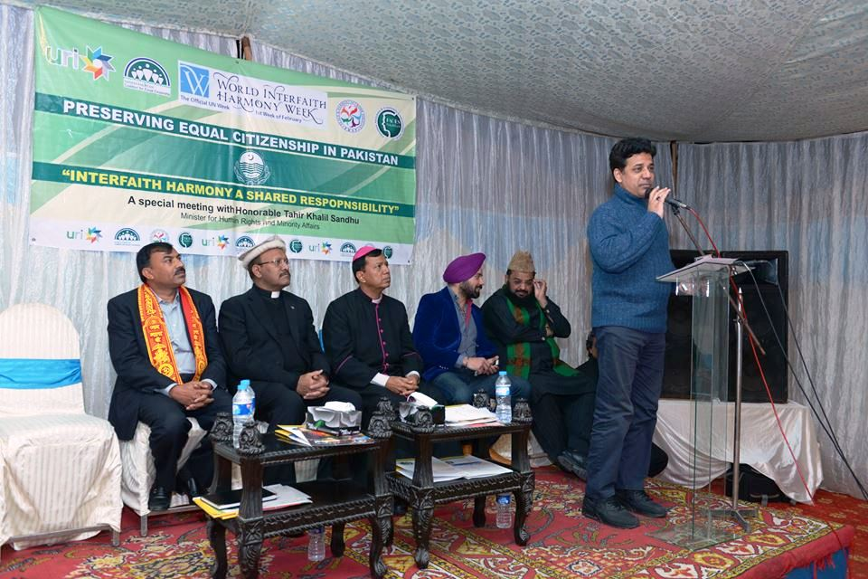
Our largest program was arranged on 3rd of February at the residence of Mr. Khalil Tahir Sandhu, Provincial Minister for Human Rights and Minorities Affairs, Government of the Punjab, Pakistan. There were around 80 participants present from 20 different likeminded organizations. The history of WIHW and UN Resolution was read by Fr. Dr. James Channan OP, URI Regional Coordinator Pakistan, Director, Peace Center, and Lahore. All were briefed about the historical background of this Resolution and the leading and significant role His Majesty, King Abdullah II played to present this Resolution at the UN. Speeches were made by leaders of Christian, Muslim Hindu and Sikh religions. It was a great manifestation of interfaith harmony and longing for peaceful coexistence and justice for all. The role of URI in promoting peaceful coexistence and tolerance for all was very much appreciated. The role of UN in promoting world peace and dialogue among religions was highly admired. Several dignitaries expressed their views about the World Interfaith Harmony Week and how it can bring many significant results in Pakistan and around the globe.
His Grace, Sebastian Shaw, Archbishop of Lahore and Chairman, Catholic Commission for Interreligious Dialogue and Ecumenism Pakistan, Presided over the ceremony, whereas, Mr. Khalil Tahir Sandhu, Provincial Minister was the Chief Guest . Archbishop Sebastian said, that we assume the negative thoughts for anyone to whom we don’t know we develop conflict between others without any reason we hate, conflict and develop the violence which is absolutely wrong which is not allowed by the point of view of our religions and society. When we know each other then we can develop positive thoughts then the love and religious harmony will create and we think this is their part of life to love each other. We have to assure that all religions are United and did not hear from the terrorism and being brave we have work together and made the peaceful Pakistan which is our beloved country.
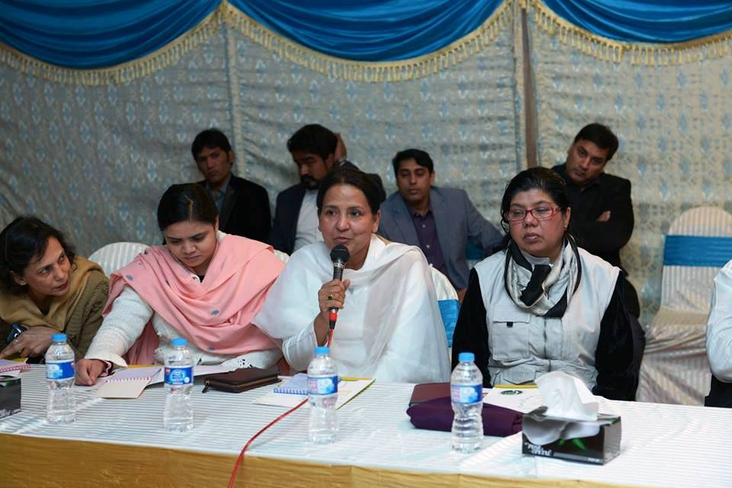
Mr. Khalil Tahir Sandhu, Provincial Minister for Human Rights and Minorities Affairs, Government of Punjab said that all over the world there is a great wave of terrorism, therefore, together we have to unite with each other for the betterment of humanity thus the religious harmony and peace will be promoted. We have to think that in terrorist net work there well learned and educated and we are observing that youth male and female are entering in the net work of terrorist which is very dangerous trend. It is a grave need of time to think and work more strongly to creating religious harmony and peace and love. Let us unite and stand for creating religious harmony and brotherhood.
Maulana Abdul Khabir Azad, Grand Imam of the Badshahi Mosque, Lahore and former URI Global Trustee and Allama Zubair Abid Chairman Peace and Harmony Network Pakistan, stress interfaith harmony for the sake and love of Prophet Muhammad (PBUH ). Nobody is allowed to burn the non Muslims places of worship because the religion of Islam does not teach violence. Everybody should be in safe hand of Muslim in their daily life and behaviors. Maulana Khabir Azad said that I along with Bishop Sebastian Shah and Fr. James Channan OP visited Germany in 2015 and we visited together Churches and Mosques for World Peace and love with the spirit of love of God Love of Man and this true example of religious harmony. It was highlighted and appreciated by the religious leaders throughout the world and it is very important that such activities be continue all over the world and of Peace and love be spread.
Abdul Fateh, GR Chishti Coordinator of Karachi CC and recipient of First Prize and Gold Medal for WIWH 2015 was also present. He showed to all the WIHW Gold Medal and Certificate, received from His Majesty, King Abdullah of Jordan. He said today program is wonderfully organized. We have to promote Interfaith Harmony all over the world. It is great honor for me that I am the Winner of WIHW 2015 Award.
Tarangeet Singh, a Sikh Youth Leader and Pandat Lal Khokhar, a Hindu leader gave messages of unity, harmony, love and peace and stress that together we can face the terrorism in Pakistan.
Fr. James Channan OP, URI Regional Coordinator, Pakistan/Asia and Director Peace Center said that I am thankful for all the dignities for their participation and their valuable speeches and through full suggestion for creating religious harmony in Pakistan and message of peace and love man and Love of God is spreading. In Pakistan where there Challenges of terrorism/ I am thankful Mr. Javaid William, Coordinator of FACESS who is our partner of this event.
Reported by:
Fr Dr. James Channan OP
Director, Peace Center, Lahore, Pakistan. www.peacecener.org.pk
Regional Coordinator, URI (United Religions Initiative) Asia Region, Pakistan
www.uripakistan.org
Cell> +92- 300 8730 669
Email: jchannan@gmail.com

