REPORT
CELEBRATION OF WORLD INTERFAITH HARMONY WEEK OF UN 2015 HOSTED BY `UNIVERSAL INTERFAITH PEACE MISSION` WITH KIND COORDINATION OF `BAHAWALNAGAR CAMPUS OF ISLAMIA UNIVERSITY OF BAHAWALPUR`
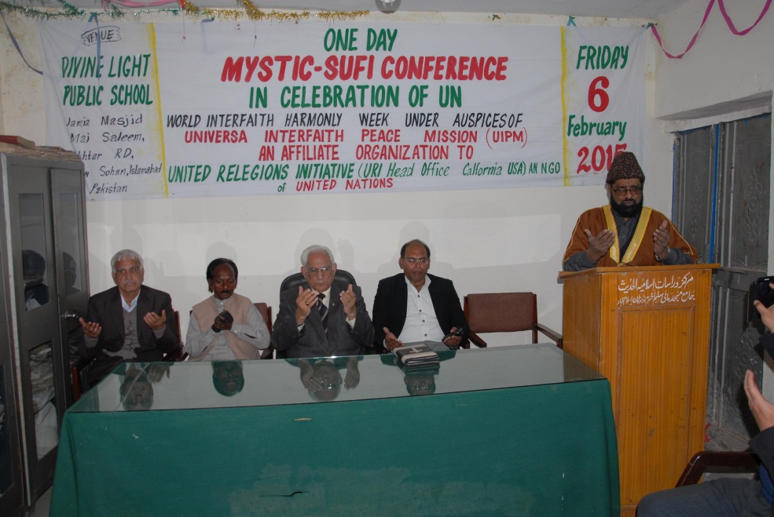
Dr Allama G R Chishti praying for peace and harmony on stage left to right there are seen prof. Mehrdad, Mr Om Parkash, Mr Ahmad Raza Qusoori Advocate and Pastor Suleman Naseri
- WIHW on Roz Tv Pakistan
Friday 6 February at one pm Dr Allama G R Chishti who is also a Tv program presenter at Roz Tv Pakistan and presents every Friday a program in the name and style of `Roz-e-Roshan-meaning Bright Day. He in his program mentioned abut WIHW that ` This week-the first week of February every year has been set aside by the United Nations to be celebrated as an annual event as the `World Interfaith Harmony Week` to spread the message of peace and harmony among all groups of humanity, thousands of peace loving people and individuals are engaged in celebrating the event and it is so important that in our country of Pakistan there is a Federal Ministery on the interfaith harmony name sake. That`s why it is appropriate to mention this program in our current affairs`.

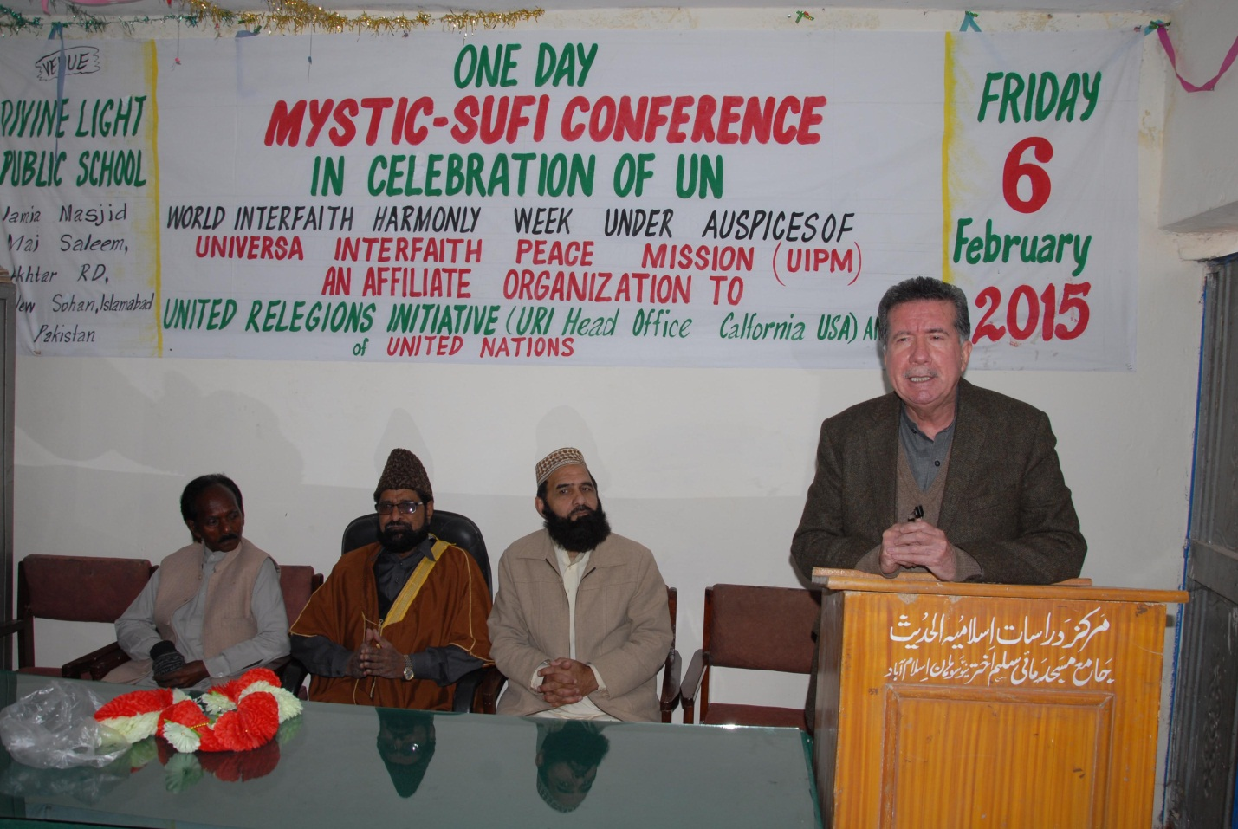
Mr Afrasiab Khan Khatak Chairman Human Rights Committee Senate Pakistan Addressing the Conference`s First Session while Sofi Zuhrab Sahib and Dr Allama Chishti and Om Parkash sitting on stage
WIHW in Friday Sermon At
Jame Masjid Mai Saleem Akhtar
New Sohan Islamabad
The same Friday 6 February Dr Allama G R Chishti who is President Modern Islamic Studies Centre Islamabad as well as he is Khateeb at the Centre`s Mosque where he delivered sermon on the subject of World Interfaith Harmony weektime from 1.30-2pm, saying that this event is the fruit of Common Word initiative taken by the Hashemite Kindom of Jordan whose King is from 41 generation of progrny of the prophet Muhammad Peace be upon Him, therefore he said that its celebration has become somrthig religious observance for us Muslims particularly.
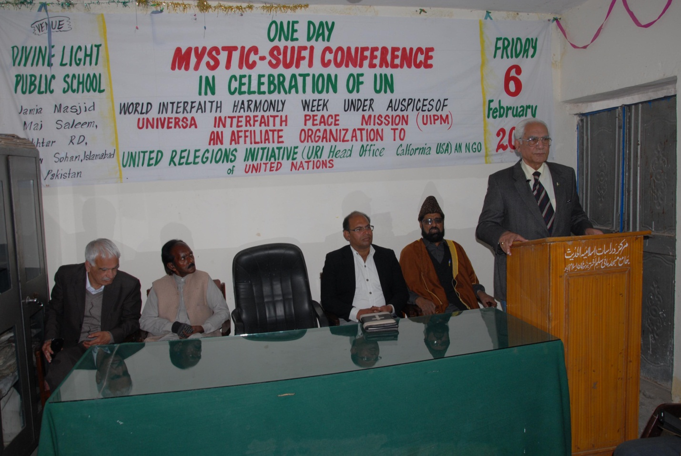
Mr Ahmad Raza Qusoori Advocate Supreme Court Pakistan Addressing the Confrerence`s Second Session
Celebration of WIHW at Divine Light
Public School Islamabad in the form
of Mystic – Sofi Conferencefrom 230-09 pm
On 6 February 2015 after Jumuah prayer at 2.30 pm the proceedings of the Mystic –Sofi Conference were commenced, Dr Allama G R Chishti opened the session by a collective prayers for peace and harmony , Qari Al-shiekh Badiuzman recited some verses fron the Holy Quran starting from the Vese of Kalema Sawaa and following that other Holy Scriptures were recited such as Sacred Torah and Sacred Evangels as well as passages from Granth Sahib and Vaids were recited to show the real mutual respect to each other`s divine books, has been established since first celebration of WIHW in 2011. The Conference was held under auspices of Universal Interfaith Peace Mission , it had two sessions at first session Mr Afrasiab Khan Khatak was Chief Guest while at the Second Session Mr Ahmad Raza Qusoori was the Chief Guest , Dr Allama G R Chishti presided over the both Sessions.
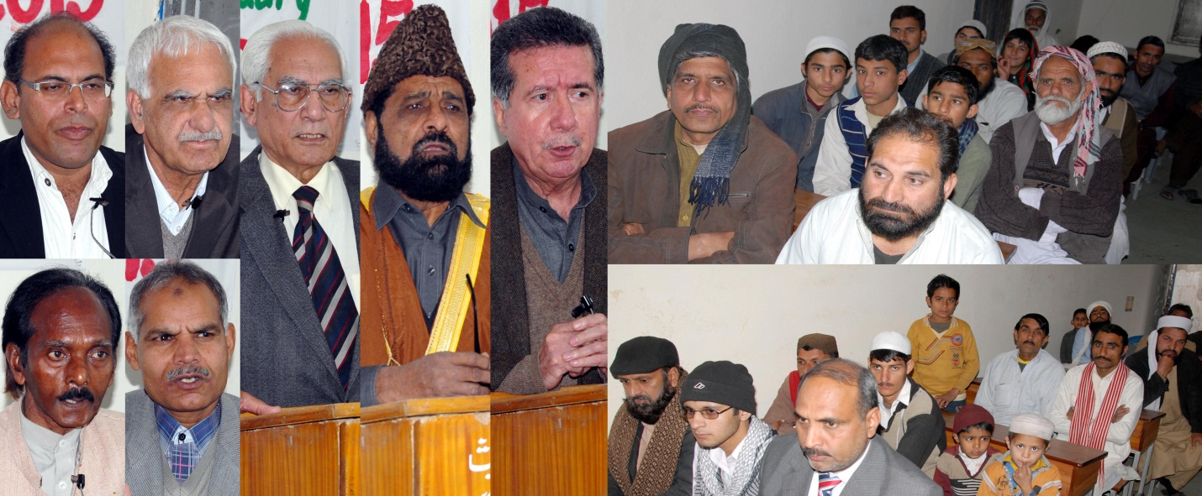
The picture of the guest speakers and audience which was issued to the Press.
The conference was attended and addressed by the representatives from Muslim Christians Hindu Siekh and Baha`I faiths, the speakers emphasized on the peace among all sections of humanity regard less of their caste color tongue or region as well as their creeds and religions.
They aspire that peace may prevail among all faiths all groups who even blong to unfaith they also condemned all sorts of terrorism and wished peace among the children of Abraham (may peace and blessings of Allah be upon him ) both Bani Ismail and Israil as Eminent Isaac and Ishmael were both apple of eyes of the Great Abraham ( AS W S), the especial prayer were made for Arb and Israel equally as they may settle their problems by dialogue and Gaza was mentioned in prayers as to be renewed again.
They paid homage to HM King Abdullah II of Hashemite Kingdom and especial Thanks to HRH Dr Professor Prince Ghazi Ibn Muhammad Ibn Talal who have been prime mover of the process which resulted in unanimous resolution by the UN General Assembly to celebrate World Interfaith Harmony Week every year as ans annual official event.
The program was fully covered by electronic and print media , it was recorded and preserved by audio and video devices Our Roze Tv flehed the news of WIHW celebration at Nine News on 6 February 2015.
The program was fully covered by electronic and print media , it was recorded and preserved by audio and video devices Our Roze Tv flehed the news of WIHW celebration at Nine News on 6 February 2015.
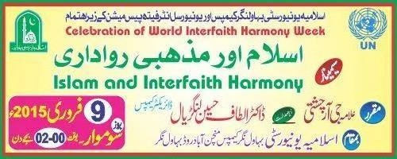On 9 February 2015 a seminar was organized by the kind cooperation of the respected , and the most moderate Dr Altaf Husain Langrial Director of Bahawalnagar Campus of Islamia University Bahawalpure, it was a momentous congregation at newly built modern buildings all religions as well as all denomination were invited Professor Shafeeq Ahmed and other Professors of Government`s Colleges of Distt. Bahawalnagar were present spacialy the leaders of tomorrow students of higher education attended te function at a large scale and listen to the words of peace and harmony very attentively and showed great interest in the cause of peace as they ere seen notting down points advanced by the speakers on he theme of interreligious peace and harmony. Dr Altaf Husain presided over the meeting whie Dr Allama G R Chishti delivered special talk on the religious tolerance and Islam he poited out that Islam is the most tolerant religions and at the same time it the most misunderstood ,so long as he said reality is concerned the study of Al- Quran may clear te point as it is filled with facts about both Chritianity and Judaism Allama Chishti said there is only 4 time name of the prophet of Islam is mentioned in the Holy Quran while name of Jesus Christ has repeated 25 time , there no name of any relative of the prophet (PBUH) no name his respected mother , daughters, and or wives but Jesus Christ`s Maternal grand father Imran and Mary mother of Christ have mentioned in Quran by their proper name , also 93 passages of Quran speaking directly about Jesus ans may Chapter are after name sake of Jesus and Children of Israel such as Al-Imran Maiedah Kahf Mar and l-Anbya and Bani Israel are ample proof of Islam being a great tolerant religion, however Jihadies`s attitude is inferred from their misinterpretation of the Holy Quran and they are out of controle of muslim ummah may allah give them guidance to behave reposibily, Amin.

