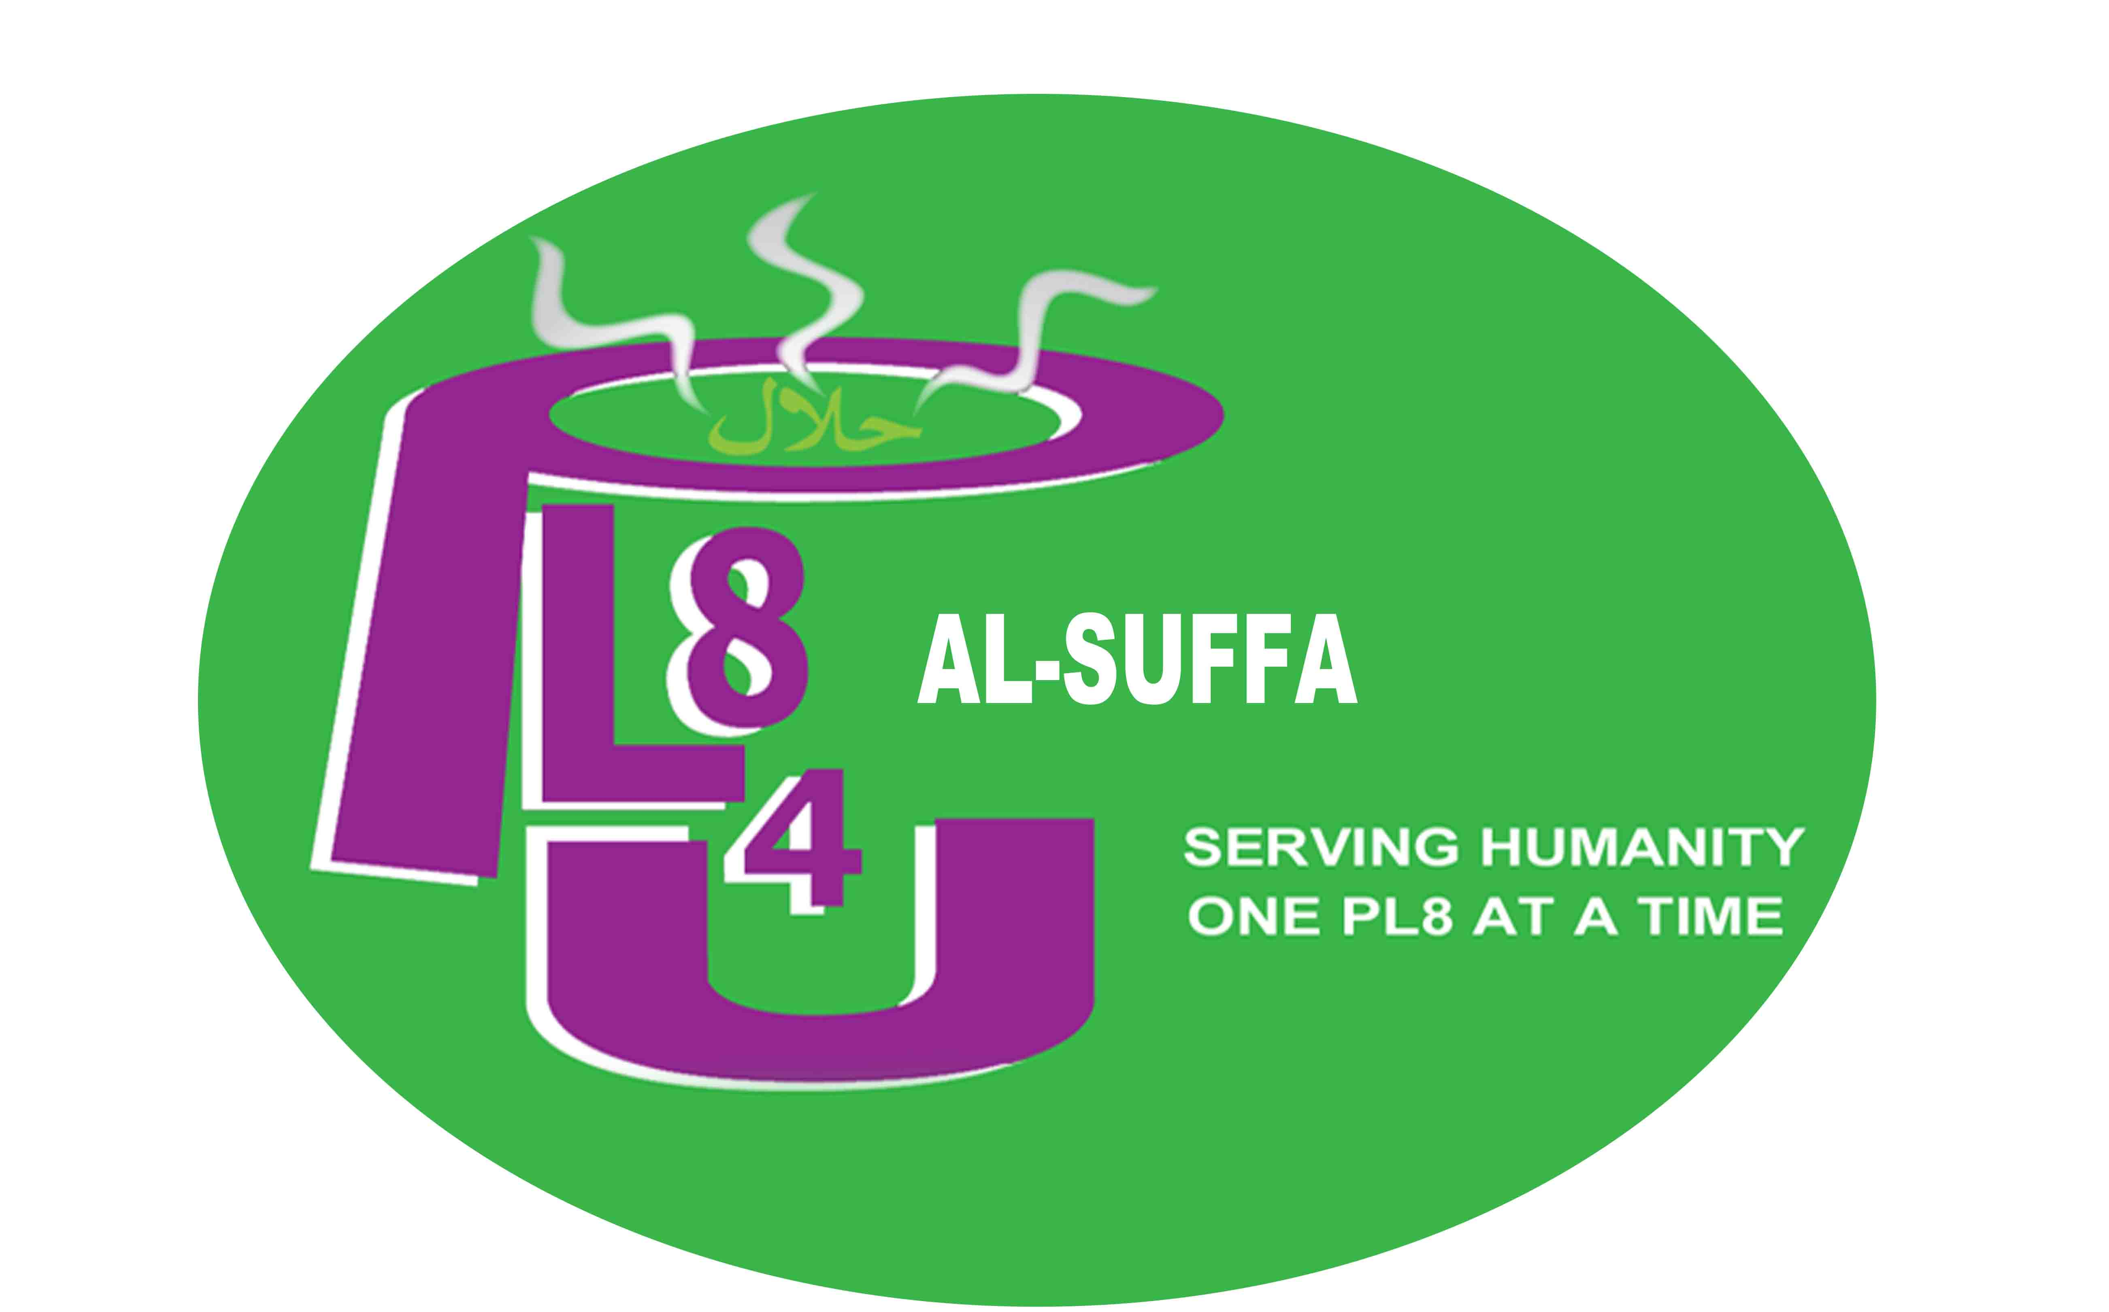

PL84U AL-SUFFA PRESENTS
‘SIGNICANT THREADS OF FAITHS’
Wednesday 7th February 2018

PL84U AL-SUFFA is a small charity based here in Walthamstow, in the East part of London, United Kingdom being one of the 5th richest countries in the world.
In terms of diversity of backgrounds and culture, London boasts many sizeable communities coming from around the globe. For many of the communities, faith is important and a fountain source of ones identity.

We are a cross-community interfaith initiative providing hot meals, companionship, food bank, clothes bank and pampering sessions for the elderly, homeless and people in need of faith and non-faith groups.

Our key aim is to help tackle poverty, cultural deprivation, isolation and bringing together diverse communities facing hardship. We accomplish this by partnering up with institutions relevant to service users’ needs and providing a safety net for the vulnerable.

We are not only passionate about bringing together people of all faiths, beliefs and non-beliefs. We truly believe that we can never stop building bridges and continue in reaching out to all the people in our communities, communities of all social groups and especially people who are facing hardship, as when people are forced into these situations, feelings of resentment towards others who are different can be widely spread due to misrepresentation of social media.

PL84U AL-SUFFA organised an event to mark “The World Interfaith Harmony Week’ and invited leaders of all faiths and non to speak about Peace, Harmony and the Importance of working together for the ‘Common Good’. PL84U AL-SUFFA opened the doors of Walthamstow Town Hall and hosted over 450 people from all faiths, backgrounds, beliefs and social groups to raise awareness of not only our similarities but also to be able to celebrate our differences, as these differences are what makes us unique, and one of these differences is the way we dress in our everyday lives and or for when we worship.

HM King Abdulla II of Jordan, his initiative which started in 2007of The World Interfaith Harmony Week gives a platform to gather people of all faiths, beliefs and non as well as speakers from all faiths reiterating the same values we all hold, the same common goals we all share about how are faiths and beliefs assist us in promoting peace and harmony, with the addition ‘Love of the Good and Love of the neighbour’ all united by the one common theme.

‘Significant threads of faiths’ what does it mean to some:

Threads of fabric that when put together makes a beautiful garment that is made and worn to clothe ourselves, and also how the clothes are worn differently, covering your body and your head.

Threads, meaning all our different faiths put together as one garment which also means when we as faith communities, beliefs and non-beliefs work together, unite together we can be stronger, just as a piece of fabric becomes stronger when a multitude of threads are woven together.
Once interlinked, they form a tight bond and when working together the threads become stronger.

The colours, textures of threads are representatives of people of different colours, different faiths and beliefs again when we have a good understanding and respect for each other’s similarities and celebrate our differences and stand together we are more powerful.

Apologies were sent from our Council Leader Cllr.Clare Coghill and our Cllr. Revd. Paul Braham a representative from the Jewish community who were not able to attend due to family emergency.

We were honoured with guests from all social backgrounds, Madam Mayor Cllr. Yemi Osho (First Citizen), HM Deputy Lieutenant Major Jeremy Fern, Shaykh Ghulam Rabbani, Shaykh Zymer Salihi of Shaykh Nazim Sufi Centre, Shaykh Mohamed Ali Harrath of Islam Channel, The Royal British Legion and many more distinguished guests. We collaborated with many organisations from our local community as well as from Central London.

PL84U AL-SUFFA were able to promote and spread the message of the World Interfaith Harmony Week to people who would not normally get an opportunity to attend such events as, it was important this message was spread amongst people who will be able to implement it into their daily lives and will action and portray the message of Peace and Harmony, working together for the common good. To reiterate this message over 350 people signed a pledge.

Pledge:

We pledge our desires as Londoners of this great city, and as leaders and members of our wider community, we will continue to work together to ensure that we all try to live in peace, harmony and work together for the common good and for the betterment of all.
We will work together endlessly to oppose and encourage best practice.
We stand together in solidarity with all, and speak as advocates for those who have no voice by ensuring to use the power of words for those who are subject to discrimination, regardless of ethnicity, culture or sexuality orientation.
We pledge to live by this declaration in our lives and in the way that we engage with others.

Our aim is for the council to mark the World Interfaith Harmony week as part of their calendar.

We ensured that we collaborate with as many organisations representing the many faiths and beliefs, from adults and children of all ages and abilities and social groups.
The organisations included ‘Leyton Six Form College’ with the 3D exhibition of a community hub and places of worship, over 50 students participating with hospitality on the evening, tutors and learners from Disability Resource Centre with their beautiful works of art of the ‘faith symbols’ which were on display.

The London Borough of Waltham Forest ‘Young People Advisory Group’, The Scouts group, who all supported PL84U AL-SUFFA with the running of the event.

Brilliant performances on the evening from ‘Voice of Peace Choir’, Gospel Singer, Spoken Word. Qasida Group, Dhervish Swirler, a theatre performance on ‘homelessness’ .

PL84U AL-SUFFA sincerely believe that our commitment to our faiths does not need to be compromised in order to live peacefully and coexist.

